|  |  |  |
| --- | --- | --- |
|  | UNIVERSITY OF CRAIOVA  FACULTY OF AUTOMATICS COMPUTERS AND ELECTRONICS  DEPARTAMENT OF COMPUTERS AND INFORMATION TECHNOLOGY |  |

DIPLOMA PROJECT

Ileana Vasilică

SCIENTIFIC COORDINATOR

Prof. dr. ing. Mihai Mocanu

July 2022

CRAIOVA

|  |  |  |
| --- | --- | --- |
|  | UNIVERSITY OF CRAIOVA  FACULTY OF AUTOMATICS COMPUTERS AND ELECTRONICS  DEPARTAMENT OF COMPUTERS AND INFORMATION TECHNOLOGY |  |

INTELLIGENT SYSTEM FOR ORIENTATION AND FLEXIBLE ORGANIZATION OF STUDENT AND TEACHER SCHEDULE

Ileana Vasilică

SCIENTIFIC COORDINATOR

Prof. dr. ing. Mihai Mocanu

July 2022

CRAIOVA

*„Focus on being productive instead of busy.”*

*Tim Ferriss*

**DECLARAȚIE DE ORIGINALITATE**

Subsemnata ILEANA VASILICA, student la specializarea CALCULATOATE ENGLEZA din cadrul Facultății de Automatică, Calculatoare și Electronică a Universității din Craiova, certific prin prezenta că am luat la cunoştinţă de cele prezentate mai jos şi că îmi asum, în acest context, originalitatea proiectului meu de licenţă:

* cu titlul “Intelligent System for Orientation and Flexible Organization of Student and Teacher Schedule”,
* coordonată de PROF. DR. ING MIHAI MOCANU,
* prezentată în sesiunea IULIE 2022.

La elaborarea proiectului de licenţă, se consideră plagiat una dintre următoarele acţiuni:

* reproducerea exactă a cuvintelor unui alt autor, dintr-o altă lucrare, în limba română sau prin traducere dintr-o altă limbă, dacă se omit ghilimele şi referinţa precisă,
* redarea cu alte cuvinte, reformularea prin cuvinte proprii sau rezumarea ideilor din alte lucrări, dacă nu se indică sursa bibliografică,
* prezentarea unor date experimentale obţinute sau a unor aplicaţii realizate de alţi autori fără menţionarea corectă a acestor surse,
* însuşirea totală sau parţială a unei lucrări în care regulile de mai sus sunt respectate, dar care are alt autor.

Pentru evitarea acestor situaţii neplăcute se recomandă:

* plasarea între ghilimele a citatelor directe şi indicarea referinţei într-o listă corespunzătoare la sfărşitul lucrării,
* indicarea în text a reformulării unei idei, opinii sau teorii şi corespunzător în lista de referinţe a sursei originale de la care s-a făcut preluarea,
* precizarea sursei de la care s-au preluat date experimentale, descrieri tehnice, figuri, imagini, statistici, tabele et caetera,
* precizarea referinţelor poate fi omisă dacă se folosesc informaţii sau teorii arhicunoscute, a căror paternitate este unanim cunoscută și acceptată.

Data, Semnătura candidatului,

|  |  |  |
| --- | --- | --- |
|  | UNIVERSITATEA DIN CRAIOVA  Facultatea de Automatică, Calculatoare şi Electronică  Departamentul de Calculatoare și Tehnologia Informației | Aprobat la data de  …………………  Şef de departament,  Prof. dr. ing.  Marius BREZOVAN |

**PROIECTUL DE DIPLOMĂ**

|  |  |
| --- | --- |
| Numele și prenumele studentului/-ei: | Vasilica Ileana |
| Enunțul temei: | *Intelligent System for Orientation and Flexible Organization of Student and Teacher Schedule* is an application which helps both students and teachers to find classroom easier and to view own schedule. In additional for teacher the app comes with one more option to add a new activity are choose an empty room for it. |
| Datele de pornire: | The starting point was to create a web application that can be easily used from any laptop, tablet or phone that has internet access.  As technologies we decided to use: Java 8, Spring with Spring boot framework, HTML, Bootstrap 5, and CSS. |
| Conținutul proiectului: | The first chapter is an introduction one. It presents the purpose and motivation of the chosen topic, but also continues a short presentation of the chapters.  The second chapter is more theoretical because in this are explained the tools and frameworks that I used to create and implement both the project and the document itself.  The third chapter is the longest and most important from my point of view. Here are resented the pre-development steps (diagrams, database, system architecture) and the implementation of each functionality both front-end and backend part.  The last chapter is the finale one. It describes personal general impressions and what can be improve upon application. |
| Material grafic obligatoriu: |  |
| Consultații: | On-side (in university) and online (using google meet)  When needed or were required, periodicals, regular (weekly) |
| Conducătorul științific  (titlul, nume și prenume, semnătura): | Prof. Dr. Ing MIHAI MOCANU |
| Data eliberării temei: | 15.10.2021 |
| Termenul estimat de predare a proiectului: | 15.06.2022 |
| Data predării proiectului de către student și semnătura acestuia: | 25.06.2022 |

|  |  |  |
| --- | --- | --- |
|  | UNIVERSITATEA DIN CRAIOVA  Facultatea de Automatică, Calculatoare şi Electronică  Departamentul de Calculatoare și Tehnologia Informației |  |

**REFERATUL CONDUCĂTORULUI ȘTIINȚIFIC**

|  |  |
| --- | --- |
| Numele și prenumele candidatului/-ei: | VASILICA ILEANA |
| Specializarea: | CALCULATOARE – ENGLEZA |
| Titlul proiectului: | Intelligent System for Orientation and Flexible Organization of Student and Teacher Schedule |
| Locația în care s-a realizat practica de documentare (se bifează una sau mai multe din opțiunile din dreapta): | În facultate □ |
| În producție □ |
| În cercetare □ |
| Altă locație: [*se detaliază*] |

În urma analizei lucrării candidatului au fost constatate următoarele:

|  |  |  |  |  |  |
| --- | --- | --- | --- | --- | --- |
| Nivelul documentării | | Insuficient  □ | Satisfăcător □ | Bine  □ | Foarte bine  □ |
| Tipul proiectului | | Cercetare  □ | Proiectare  □ | Realizare practică □ | Altul  [*se detaliază*] |
| Aparatul matematic utilizat | | Simplu  □ | Mediu  □ | Complex □ | Absent  □ |
| Utilitate | | Contract de cercetare □ | Cercetare internă □ | Utilare  □ | Altul  [*se detaliază*] |
| Redactarea lucrării | | Insuficient  □ | Satisfăcător □ | Bine  □ | Foarte bine  □ |
| Partea grafică, desene | | Insuficientă  □ | Satisfăcătoare □ | Bună  □ | Foarte bună  □ |
| Realizarea practică | Contribuția autorului | Insuficientă  □ | Satisfăcătoare □ | Mare  □ | Foarte mare  □ |
| Complexitatea  temei | Simplă  □ | Medie  □ | Mare  □ | Complexă  □ |
| Analiza cerințelor | Insuficient  □ | Satisfăcător □ | Bine  □ | Foarte bine  □ |
| Arhitectura | Simplă  □ | Medie  □ | Mare  □ | Complexă  □ |
| Întocmirea specificațiilor funcționale | Insuficientă  □ | Satisfăcătoare □ | Bună  □ | Foarte bună  □ |
| Implementarea | Insuficientă  □ | Satisfăcătoare □ | Bună  □ | Foarte bună  □ |
| Testarea | Insuficientă  □ | Satisfăcătoare □ | Bună  □ | Foarte bună  □ |
| Funcționarea | Da  □ | Parțială  □ | Nu  □ | |
| Rezultate experimentale | | Experiment propriu  □ | | Preluare din bibliografie  □ | |
| Bibliografie | | Cărți | Reviste | Articole | Referințe web |
| Comentarii  și  observații | |  | | | |

În concluzie, se propune:

|  |  |
| --- | --- |
| ADMITEREA PROIECTULUI  □ | RESPINGEREA PROIECTULUI  □ |

Data, Semnătura conducătorului științific,

**PROJECT SUMMARY**

Nowadays all around us represents technology and people spend 80% of their time on devices using a certain type of application. For an application to be good, it must come to the aid of users and solve a certain problem that they have encountered. This is ready when it meets the following two requirements: all the functionalities that were imposed from the beginning have been implemented and was tested.

The implemented application comes to the aid of both students and teachers. This offers the user the opportunity to search for a certain class, but also to see their own schedule. Furthermore, for teachers the app gives them the opportunity to add a new activity, this can be of the laboratory, course, seminary, or project type, and generates a list of free classes where they can take their class time.

To facilitate the work of developers, a lot of tools have been implemented that help the rapid development of a quality application. We will discuss these in more detail in the following chapters.

Keywords: database management system, object-oriented programming, web-application, java, spring boot framework, spring security, mySQL

**CONTENT**

Acronyms xv

1 INTRODUCTION 1

1.1 The Scope 1

1.2 The Motivation 1

1.3 Document Structure 2

2 DEVELOPMENT TOOLS AND CONCEPTS 4

2.1 Project Technical Requirements 4

2.2 Languages Used 5

2.2.1 Java 5

2.2.2 HTML 7

2.2.3 CSS 8

2.2.4 Thymeleaf 9

2.2.5 SQL 10

2.3 Frameworks 12

2.3.1 Spring Boot 12

2.3.2 RESTful API 14

2.3.3 Hibernate 15

2.3.4 Lombok 16

2.3.5 Spring Security 16

2.3.6 Junit5 17

2.3.7 Bootstrap 19

2.4 Database 20

2.5 Development Tools 23

2.5.1 IntelliJ IDE 23

2.5.2 Maven 24

2.5.3 Postman 24

2.5.4 Creately 25

2.5.5 Draw.io 26

2.5.6 MySQL Workbench 26

3 APPLICATION DEVELOPMENT PROCESS 27

3.1 Expected Impact and Functional Requirements 27

3.1.1 How Impact This Application Real Word? 27

3.1.2 Functional Requirements 28

3.1.3 Non-Functional Requirements 29

3.2 Pre-Development Steps 31

3.2.1 Database Model 31

3.2.2 Use Case Diagrams 35

3.2.3 Use Case Scenario 36

3.2.3.1 High-level 36

3.2.3.2 Primary Use Case Summary 38

3.3 System architecture 40

3.3.1 Presentation Layer 40

3.3.2 Business Layer 42

3.3.3 Persistence Layer 43

3.3.4 Database Layer 44

3.4 Implementation of Requirements 45

3.4.1 Login Functionality 45

3.4.2 Student Functionalities Implementation 47

3.4.3 Teacher Functionalities Implementation 52

3.4.4 Admin Functionalities Implementation 57

3.5 Testing 64

4 CONCLUSION 65

4.1 General Conclusions 65

4.2 Future Developments 66

BIBLIOGRAFIY 68

A. SOURCE CODE 70

B. WEB APPLICATION 70

C. CD / DVD 71

Index 72

**LIST OF FIGURES**

*Figure 2‑1 : the logos for the languages and frameworks used* 5

*Figure 2‑2 : relation between source code and machine language* 6

*Figure 2‑3 : example of HTML code* 8

*Figure 2‑4 : difference between page with CSS and without CSS* 9

*Figure 2‑5 : thymeleaf dependencies* 10

*Figure 2‑6 : types of SQL commands* 12

*Figure 2‑7 : spring and spring boot dependencies* 13

*Figure 2‑8 : Spring Boot application architecture* 14

*Figure 2‑9 : hibernate futures* 16

*Figure 2‑10 : lombok annotations* 16

*Figure 2‑11 : example of how Sprin Security works* 17

*Figure 2‑12 : jUnit dependency* 18

*Figure 2‑13 : Responsive web application with Bootstrap* 20

*Figure 2‑14 : Database Management System flow* 21

*Figure 2‑15 : Create/Read/Update/Delete operations on database* 21

*Figure 2‑16 : types of databases* 22

*Figure 2‑17 : IntelliJ IDEA logo* 23

*Figure 2‑18 : create new IntelliJ project* 23

*Figure 2‑19 : Maven logo* 24

*Figure 2‑20 : Client-Server connection with postman* 24

*Figure 2‑21 : Creately logo* 25

*Figure 2‑22 : draw.io logo* 26

*Figure 2‑23 : MySQL logo* 26

Figure 3‑1 : non-functional requirements 30

Figure 3‑2: database relational model 32

Figure 3‑3 : User-Student-teacher database relationship 34

Figure 3‑4 : activity diagram 35

*Figure 3‑5: application architecture* 40

*Figure 3‑6: application architecture explicitly diagram* 40

*Figure 3‑7: user authentication dto* 41

*Figure 3‑8: user entity* 41

*Figure 3‑9: validations on dto* 43

*Figure 3‑10: repository example* 43

*Figure 3‑11: user repository query example* 44

*Figure 3‑12: flow architecture* 45

Figure 3‑13: login page 46

Figure 3‑14: login endpoint 46

*Figure 3‑15: student home page* 47

*Figure 3‑16: search functionality* 48

*Figure 3‑17: search functionality - response* 48

*Figure 3‑18: search functionality endpoint* 49

*Figure 3‑19 : search functionality implementation* 49

*Figure 3‑20: find image endpoint* 49

*Figure 3‑21: image utils class* 50

Figure 3‑22: Schedule functionality page 50

*Figure 3‑23: get schedules endpoint for students* 51

*Figure 3‑24 : view schedule function from student service* 51

*Figure 3‑25 : Profile page for a student* 51

Figure 3‑26: update personal date endpoint - for students 52

Figure 3‑27: implementation of update method in service 52

*Figure 3‑28: search classroom functionality – teacher* 53

*Figure 3‑29: view schedule functionality - teacher* 53

*Figure 3‑30 : edit profile functionality – teacher* 54

*Figure 3‑31: manager activities - teacher functionality* 54

*Figure 3‑32: add new activity - teacher functionality* 55

*Figure 3‑33: add new activity functionality for teacher* 56

*Figure 3‑34: admin home page* 57

*Figure 3‑35: CRUD on classroom entity - admin functionality* 57

*Figure 3‑36: getClassroom() method in controller* 58

*Figure 3‑37: delete method on classroom in controller* 58

*Figure 3‑38: delete method on classroom in service* 58

*Figure 3‑39: CRUD operations on USER entity* 59

*Figure 3‑40: example of StudetDao class for add new entry* 59

*Figure 3‑41: example of TeacherDao class* 60

*Figure 3‑42 : list of all activities for admin user* 61

*Figure 3‑43 : getActivities() method from controller* 61

*Figure 3‑44 : delete method from activity controller* 62

*Figure 3‑45 : update method from activity controller* 62

*Figure 3‑46 : save method from activity service* 63

*Figure 4‑1 : mapping process* 67

**LIST OF TABLES**

*Table 1: acronyms table* xv

*Table 2 : high level use case login functionality* 37

*Table 3 : high level use case teacher -add new activity functionality* 37

*Table 4 : high level use case search classroom functionality* 37

*Table 5:high level use case view schedule functionality* 38

*Table 6:high level use case admin-CRUD on USER functionality* 38

*Table 7:high level use case admin-CRUD on CLASSROOM functionality* 38

*Table 8: high level use case admin-CRUD on ACTIVITY functionality* 38

*Table 9: primary use-case for search classroom scenario* 39

*Table 10: primary use-case for add new activity scenario* 40

*Table 11 : free classroom cases* 57

# Acronyms

*Table 1: acronyms table*

!! All the definitions from this tables are taken from the official website Wikipedia

|  |  |  |
| --- | --- | --- |
| **ACRONYM** | **FULL NAME** | **DESCRIPTION** |
| AWS | Amazon Web Services | “AWS is a subsidiary of Amazon that provides on-demand cloud computing platforms and APIs to individuals, companies, and governments, on a metered pay-as-you-go basis.” |
| DBMS | Database Management System | “DBMS is a software package designed to define, manipulate, retrieve and manage data in a database” |
| CRUD | Create-Read-Update-Delete | Operations that can be made on the relation database |
| API | application programming interface | “An API is a connection between computers or between computer programs” |
| SOAP | Simple Object Access Protocol | “Is a messaging protocol specification for exchanging structured information in the implementation of web services in computer networks” |
| WSDL | Web Services Description Language | “Is an XML-based interface description language that is used for describing the functionality offered by a web service” |
| WWW | World Wide Web | “Refers to all the public websites or pages that users can access on their local computers and other devices through the internet” |
| CSS | Cascading Style Sheets | “Is a style sheet language used for describing the presentation of a document written in a markup language such as HTML or XML” |
| XML | Extensible Markup Language | “Is a markup language and file format for storing, transmitting, and reconstructing arbitrary data.” |
| RESTful | Representational state transfer | “Is a software architectural style that was created to guide the design and development of the architecture for the WWW.” |
| HTTP | Hypertext Transfer Protocol | “Is an application layer protocol in the Internet protocol suite model for distributed, collaborative, hypermedia information systems” |
| HTML | Hypertext Markup Language | “Is the standard markup language for documents designed to be displayed in a web browser.” |
| JRE | Java Runtime Environment | “Released by Oracle is a freely available software distribution containing a stand-alone JVM” |
| JDK | Java Development Kit | “Is a distribution of Java Technology by Oracle Corporation” |
| JVM | Java virtual machine | “Is a virtual machine that enables a computer to run Java programs as well as programs written in other languages that are also compiled to Java bytecode.” |
| ORM | Object–relational mapping | “In computer science is a programming technique for converting data between type systems using object-oriented programming languages” |

# INTRODUCTION

## The Scope

The scope of this document is to describe in detail the architecture, the implementation, the tools, and the frameworks used to create my license degree project. “Orientation and Organization App” represents an application that helps teachers and students to easily find the classroom where they will have the next course or view their schedule.

“Intelligent system for orientation and flexible organization of student and teacher schedule” is my diploma project title. Even though it is a very long one, the main goal of the project was to help students find the classroom easier on campus. Initially, the application was originally designed for 1st year students, but any student of the faculty can use it. To increase the difficulty, we decided that the application can be used by teachers, and in addition, it should have an admin.

The subject of my diploma project evolved because with the coordinating professor, we decided to make this last stage of the four years of college a little more difficult. So, for teachers, the application also offers the possibility to add a new activity being generated by a list of free classes where it can take place. In this way, a simple application has become an intelligent system to help both organization and orientation

Technology is growing and we need to keep up with it. As Donny Lamey says in the article [1]: “All technologies are born out of purpose. “ and also with a well-established purpose I decided to create this application too. I chose to make a web application, because today 95% of the target group has a smartphone with internet access. Maybe it would have been a better idea for the application to be a mobile one, but if this prototype is successful, the transition will be a very easy and achievable step.

During the four years of college, I had the opportunity to learn a lot and develop my knowledge. I did not have a subject to love, and I tried to make every effort that I could give to all equally. With this last and defining project I tried to incorporate as much knowledge as possible.

## The Motivation

As the name of the publication of a great Romanian playwright says [2] that is how I felt when I got into the position of choosing my bachelor's degree. Choosing the Automation, Computer and Electronics Faculty was one of hardest choices of my life. I decided to go into engineering way in my last year of high school. And in the same way, a year before supporting the diploma project, I decided to create an application that could be useful, not just a job in vain.

Being also a student in the 1st year of the University of Craiova and having classes in several buildings, it was very difficult to find the classroom in the first months. If we have an application like the one this problem would not have existed. That was my first idea of the diploma project and that is what I will try to develop. Being a student in the 4th year and going through certain problems in my college years, I wanted to come to the aid of the new generations with a useful application that I can use every day.

The first purpose of the developed application was to offer users the opportunity to search for a particular classroom. Because students and teachers can learn where each class is quick, maximum in the first semester spent in college, I also added the option to see their schedule. Now, because we are final year students and project diploma is the most complex project accomplished, the application offers an extra functionality.

The extra option is to place the students in the corresponding classrooms considering the group they belong to and the type of activity they carry out. Because now in my faculty this action is carried out by a teacher, I decided that I would also offer the possibility for TEACHER users to be able to add a new activity and choose an appropriate class.

## Document Structure

This document is structed in 4 chapters, each one explains in a detailed mode a specific part of the application. To understand exactly what it is about and what I wanted to achieve with this project, the chapters must be read in order, because they are closely connected.

The first chapter is an overview of the project scope and my motivation. This is a more introduction one to present the main purpose of the application. It describes in detail the choice of theme, the main scop of the application and the impact that can have on people. I also presented the motivation for which I decide on this topic.

The second chapter is one more theoretical because here we will find all the tools and technologies used. The chapter will start with the presentation of the technical requirements. Then the second subchapter will present the languages used both for the front-end and back-end parts, to implement the application. Next, we will discuss about database, in principle something in general and somewhat more of a theory. And the last subchapter is the one which present the development tools used to create the application and this document.

The third chapter will be the longest one because this will explain all the aspects of the software development lifecycle of my application. The first title from this chapter is a question: “How dose impact my application real word?”, because we do not want our work to be in vain, consider that the answer to this question is an important one and with a great impact. The second subchapter presents in detail the pre-development steps which were made to start the application development. Next, we will discuss the system architecture, why we choose this one and how is implemented. This chapter ends with the longest discussion: what are the requirements of the project and how they have implemented both front-end and back-end.

The final chapter is a conclusion one in which we will discuss about the experience during the implementation of the application and last but not least about my opinion on this project. Furthermore, it will present some improvements which could be brought to the project and what functionalities we intend to further develop.

# DEVELOPMENT TOOLS AND CONCEPTS

## Project Technical Requirements

Nowadays the main purpose of an application is to be accessible, easy to use, easy to understand and most importantly, to meet all the requirements set from the beginning. To have a quality product, the developer must consider all the information he receives. When it is decided to create a new application, first, the target group is considered. Target group represents the people who will use the application developed by us every day.

To create a good application the first step is to write all requirements that will be implemented and all the ideas. After that, it is necessary to make an analysis and see if the functionalities that want to be implemented are achievable or not. Another thing to keep in mind when developing a new application is when it will be ready. As Andra Secelean says in the article [3] “time means money” and it is very important to know how to manage our time.

Any investor or client when it comes to a proposal for the development of a new application or project wants to know how long it will be ready and which is the necessary budget if it already has a budget and if it can fit in it. In addition to the list of features, tools needed to develop the application, and the technologies used, at the beginning of a new project, a well-developed plan must be made related to the actual development of the application.

The same steps described above were followed in the development of this application. First a list of general requirements was made starting from the initial idea of the application. A client is not involved, so a list related to the budget has not been made, but a plan has been made so that the application is ready by the date of the diploma project.

As the main purpose of the application, we stuck to the functionality of managing students in the classrooms, thus coming to the aid of teachers. A user who has the role of teacher can add a new activity. This can be a laboratory, seminary, course, or project type. What is very important when a new activity is add is the following data: the day on which it takes place, the start hour, the end hour, and the type of class the teacher needs. Based on the data entered by the user and the number of the students who are part of the target group or subgroup, the application will search the database for the corresponding classes that are free at the time entered.

## Languages Used

As programming languages, I choose to use the most important ones that we learned in the last four years. From my point of view, those are the most important part of the implementation. I believe that the programming language you choose when implementing an application is what defines you.

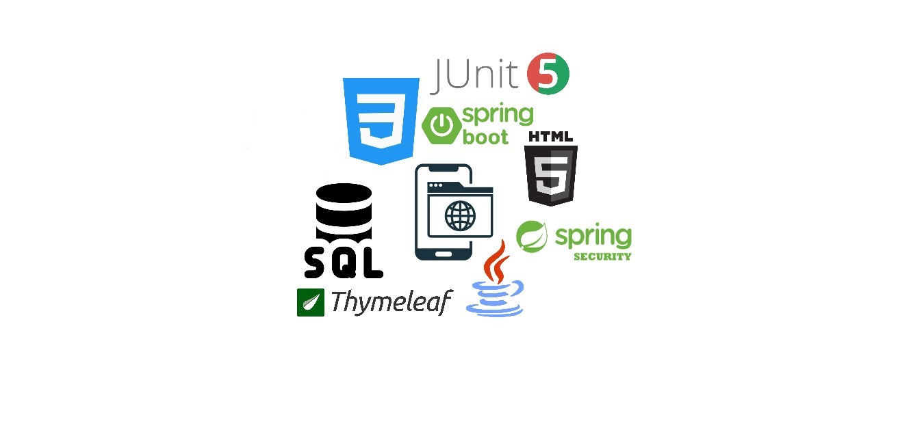

*Figure 2‑1 : the logos for the languages and frameworks used*

### Java

Java appeared as a programming language in 1995 and was created by James Goslingas sources such as [10] says. A programming language is a set of rules which converts elements into a visual programming language. Java is used to compute algorithms in computer programming and is considered a computer language. Java is a high-level and an object-oriented programming language. The main scope of James when he created this language was to have as few implementation dependencies as possible.

Java 18 is the last version of this programming language, but the most used is Java 8. From my point of view, it is important for us, as developers, that programming languages evolve rapidly, because the demand is high, and we want everything to be as accessible and easy to use as possible. When creating this programming language, its developers considered four main principles:

* to be simple and familiar – so it is object-oriented because in this way people can work more easily with it, but the origin is C++ language, which is the best known.
* to be secure, dynamic, threaded and interpreted
* to be executed with high performance: to increase the performance Java runs on JVM. As it evolves in version, so does the performance of the language
* to be portable: java software can be run on any laptop to data centers

Nowadays exist many applications and websites that will not work unless you have Java installed in your computer, and those are created mostly every day [4]. As many studies have shown, Java is one of the most widely used programming languages [5]. This is one of the reasons why I also chose it as the main programming language in my application.

In my opinion, Java offers many possibilities, and it is an accessible language. The fact that it is object-oriented makes everything seem very natural and the part I liked the most, is the fact that we can make correlations with the real world. Furthermore, for many organizations, it is recognized as one of the secure and fast programming languages with the help of which they can build their projects.

The central processing unit does not understand the sources written in a programming language, what it understands is called machine language. The machine code is the basis of the languages that a computer understands. It looks like a long sequence of one and zero because it’s in binary code.

Figure 2.2 shows the process by which the source code written by a programmer is understood by a CPU. The source code is translated to machine language using a compiler. Human just understands the source code, the CPU understand the machine language and in the back is done the conversion between these two languages. In this way it does not matter what programming language a developer uses the computer will understand always the one specific language. What matters when we write the source code is the compiler, and it differs depending on the programming language used.

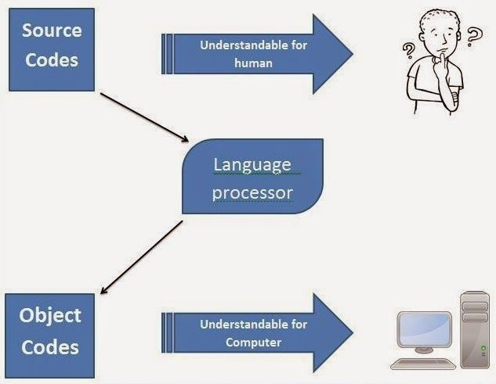

*Figure 2‑2 : relation between source code and machine language*

For a code written in Java to be understood by the CPU we need the following three core components:

* Java Development Kit (JDK): is the most important part of the Java compiler. Without it, no program written in Java could run.
* Java Virtual Machine (JVM): provides a runtime environment for Java applications. Its purpose is to convert Java bytecode into machine code. JVM is a component of JRE.
* Java Runtime Environment (JRE): contains supporting files likes JVM or libraries.

### HTML

HTML represents the standard language for web applications (WWW). This is very easy to learn and to use. The last version is HTML 5 which appeared in 2014 according to the official documentation [12]. This language was born in year 1980 due to Tim Berners-Lee. HT comes from hypertext, and this is how the connection between the web pages is made. Links represents the fundamental property of the web.

When Tim Berners developed this language, he wants to be an option for physicists so that they can communicate with each other through the internet. Therefore, HTML needed three important properties:

* platform independency – a document can be looked in the same way to different computers
* hypertext possibilities - any word, phrase, image, or other element of the document seen by a user may refer to another document
* documents structuring - allowed to convert documents from one format to another.

Since the invention of the WEB in 1989, it has remained the most popular communication tool in the world. Initially, the proposal to develop such a service appeared because of delays in correspondence between people, who use postal services. A WEB page is based on the scripting language Hypertext Markup Language and later for the graphical development of the pages were introduced the languages JS and CSS.

The communication between the web service we want to access and the browser we use is done on a stack of HTTP protocols being the first element found in a link of a web page. As access to WEB pages has become very popular, they have fallen prey to cyber-attacks and attempted fraud. To reduce the number of these computer crimes, the HTTPS protocol was introduced.

In HTML all are represented by tags. A such type of document starts with a special tag <!DOCTYPE> who is not a HTML tag. This informs the browser about what type of document expect. After that exist a prim special HTML tag that marks the begging of the document <html> which is an open-close one. As figure 2.3 shows for each type of element we want to add to our web page, HTML has a special tag. What is important to know is that this language is case-insensitive <p> is equal with <P>.

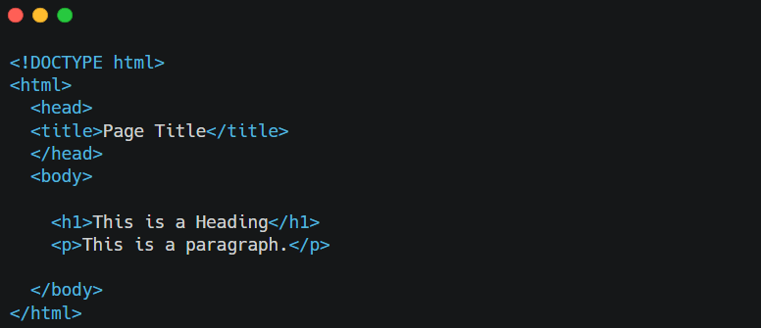

*Figure 2‑3 : example of HTML code*

To run HTML code on computer is enough to have a Text Editor, something simple like Notepad or Notepad++, or a more complex application Visual Studio Code. What is interesting about running a HTML file locally is the fact that does not even need an internet connection. This is possible because these file types (.html) are running on the local host.

When we talk about RESTful services, we can used HTTP verbs to work much easier with such an application. These verbs are POST, GET, PUT, PATCH and DELETE. As the name suggests, these are methods by which we can make structural changes, create new data, or simply view existing data.

### CSS

Cascading Style Sheets describe a document written in a markup language like HTML or XML. It is also on the left side of the JavaScript programming language. According to [6] is a stylesheet language of the open web and “is standardized across web browsers”. It helps developers work on application design. The colors or the front of a text can be easily set in a CSS file and then applied in an XML file just by entering a script. In addition to color options and text size, CSS also offers the ability to add animations.

Is important to use CSS because the design of a site becomes much easier to improve. A site that is only in black and white would not have the same impact on users as a brightly colored one. CSS offers many libraries that make working with it much easier. In addition, this language is learned very quickly. If you already know the basic language of the application you are developing and HTML, the integration of CSS will be done immediately.

In the next figure 2.4 we can see a visual difference between a web site with CSS and one without CSS. It is very easy to choose a favorite one, because the differences between the two are very large and their impact on users is remarkable. There is also the possibility of stylizing a website without CSS, but this is much more difficult. If this language still exists, there is no point in making programmers work more difficult.

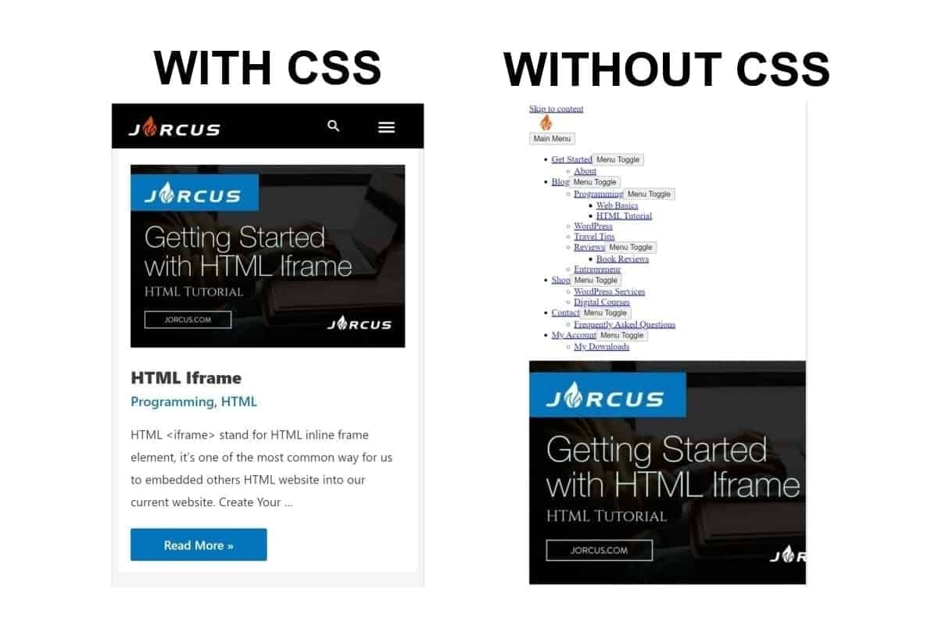

*source:* [*https://medium.com/jorcus-school/getting-started-with-css-6e69e15488da*](https://medium.com/jorcus-school/getting-started-with-css-6e69e15488da)

*Figure 2‑4 : difference between page with CSS and without CSS*

### Thymeleaf

We discuss about Java and HTML, now let’s find how we can incorporate both and obtain a web-application written in Java. Thymeleaf is the solution. It is a template engine in Java and HTML. It can be using in both web-application and non-web environment. In web application Thymeleaf provides template that can be directly opened in browser. On Internet is also official documentation [13] that provides support in case a user needs it.

If the emphasis is not on the front end, but on the back end, but both are needed in a project, Thymeleaf is the perfect choice. It integrates perfectly with applications written in Java, being developed in the same programming language. There are websites that explain from the beginning how to integrate and especially how to use this framework.

If the project being developed uses Maven and Spring, Thymeleaf's integration is very easy. Only the two dependencies shown in figure 2.5 need to be added and the whole connection process happens in the background.

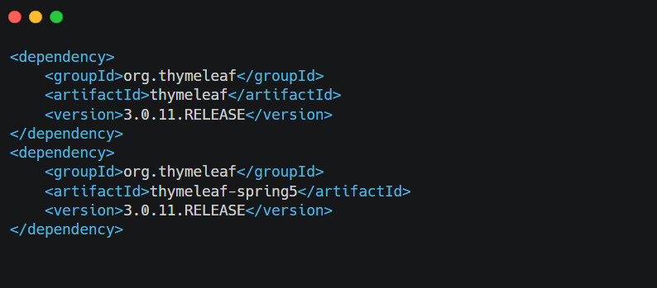

*Figure 2‑5 : thymeleaf dependencies*

In order to create the connection between endpoints written in java Controller classes and tymeleaf HTML files it is enougth to puth in the tag that indicate a specific element the next property: *th:text="#{name}"*, where:

* *th:text* is an attribute which takes his value and sets a result for the body of host tag. Onother examples of sttributes can be: *th:case, th:switch, th:field*
* *name*: is a expression specified in SES which indicate the fact that the text used by the attribute should be the message with the name key corresponding

### SQL

SQL is a structured query language as the name implies, which helps to manipulate data from a relational database according to article [14]. The origin of SQL is relational algebra. The main purpose is to delete, update, add and create schemes which involves data. It was developed in 1974 by IBM company.

What can we do with SQL? We can execute queries for database, we can retrieve data, we can insert new date, we can update existing data, we can create a new database or table, we can view existing databases, we can set permission on tables.

The base elements of the SQL language are:

* term – is a part of the queries and instructions
* expressions - they produce the tables. Tables are the basis element of the SQL language
* predicates – represents the expressions that are evaluated by SQL. The evaluation is based on Boolean logic
* queries - provides a data set received as a response based on predetermined conditions.

As Java T Point explains in the article [15] the SQL language can have multiple commands. They are grouped into the following categories:

* DDL – Data Definition Language - this category is represented by SQL commands which define the schema. Some examples of commands are CRATE, DROP, ALTER, TRUNCATE, COMMENT, RENAME
* DQL – Data Query Language - in this category are commands which can performing queries (example: SELECT command)
* DML – Data Manipulation Language - in this category are data handling commands: INSERT, UPDATE, DELETE, LOCK
* DCL – Data Control Language - these commands are permissions commands: GRANT, REVOKE.

In figure 2.6 we can see a list with all this commands and their type. In addition, TCL commands can be seen. In Transaction Control Language category are commands which deals with transactions. A transaction start with a task and ends when all the tasks are done. In this category we have commands like COMMIT, ROLLBACK, SAVEPOINT, SET TRANSACTION.

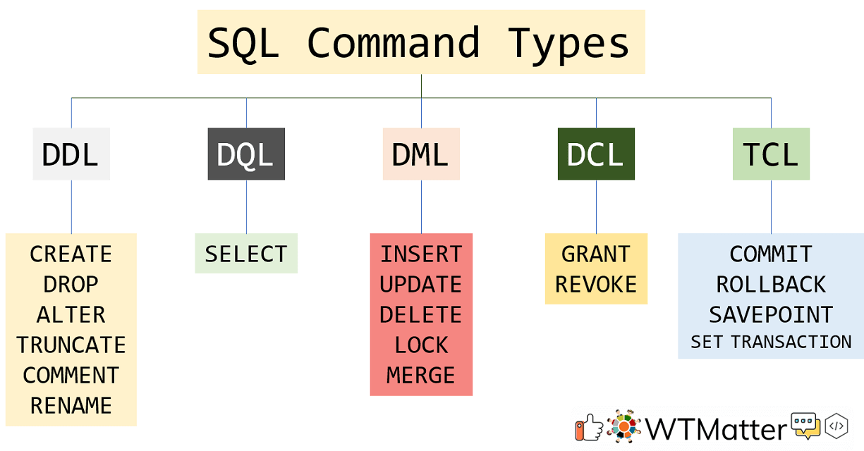

source: <https://wtmatter.com/sql-command-types-ddl-dql-dml-dcl-tcl/>

*Figure 2‑6 : types of SQL commands*

In addition to the SQL language comes a database manipulation system called MySQL. This RDMS is very popular in application web development. On internet exists many available API schemes which allow applications to be written in many programming languages to access MySQL databases (e.g., C, C++, C#, or Java).

What it is important for all users that works with SQL is the fact that for some operating systems is case sensitivity. For example, for Windows and macOS SQL is case-insensitive, while for Linux is case-sensitive. No matter what OS is running, SQL is always case sensitive for table names, but not for attribute values.

## Frameworks

Most people, especially those who are not technical, consider the framework to be a program without which a developer would not be able to create a project. This is very wrong. A framework is a software, which facilitates the process of development and integration of the various components of a project. With other words a framework represents a collection of libraries and tools which transforms ordinary tasks into repeatedly usable modules.

What are the advantages of using frameworks? As the [16] article explain: “Assists in establishing better programming practices and fitting use of design patterns, code is more secure, duplicate, and redundant code can be avoided. Several code segments and functionalities are pre-built and pre-tested. This makes applications more reliable. Testing and debugging the code is a lot easier and can be done even by developers who do not own the code. And last, but not the list the time required to develop an application is reduced significantly”.

### Spring Boot

First, the parent of Spring Boot framework is Spring. Spring represents an open-source framework developed for Java [17]. In generally an open-source platform is something whose code is accessible to anyone because it is public. So, it can be modified, shared, or enhanced by anyone. Spring provides developers with support to develop projects in a much faster and easier way. It come with some dependencies like: Spring JDBC, Spring MVC, Spring Security, Spring AOP, Spring Boot etc.

Spring was released by Rod Johnson in 2002 together with his book [7]. In 2003 this framework had been licensed by Apache 2.0. Spring Boot was published in April 2014, but the process to developed it start in October 2012 when Mike Youngstrom‏ crated a task on Jira board asking for support for container less web application. This is apart from his request: “*I think that Spring's web application architecture can be significantly simplified if it were to provided tools and a reference architecture that leveraged the Spring component and configuration model from top to bottom. Embedding and unifying the configuration of those common web container services within a Spring Container bootstrapped from a simple main () method.”*

Spring boot has come to improve the values ​​offered by Spring. With other words is an extension of the Spring framework. What brought this framework in addition to the original one it eliminated the configuration part from the beginning. We can see in figure 2.7 the two dependencies that we had to add in a Spring application and the only dependency that had to be added in a Spring boot application.

This is another improvement over the initial framework.

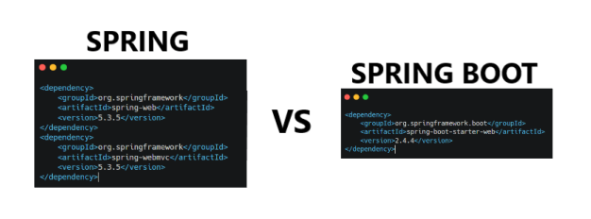

*Figure 2‑7 : spring and spring boot dependencies*

In figure 2.8 is presented the arhitecture of a Spring Boot Application. As we can see it contains four important layers and the source from which the requests are sent. We will discuss each one in order to be able to go into a little detail, because it is very important to know the architecture of such a framework.

* POSTMAN CLIENT: represents the place where the requirements are sent to the application itself. This requirements are called endpoints.
* CONTROLLER (**Presentation Layer**): this layer contains the views, handles the HTTP request which contains JSON paramters. This paramters are converted to Java objects \which are called DTOs. (Data Transfers Objects). Furhermore, this layer deals with the authentication part.
* SERVICE (**Business Layer**): in this layer is all the business logic for a project. Also, in this layer takes place the part of authorization and validation of data.
* REPOSITORY (**Persistence Layer**): this layer represents tge logic from database. Here are presented operations like add a new element in DB, update something from DB etc.
* DATABASE (Database Layer): this layer contains the satabase itself. The database can be MySql, MongoDB or others.

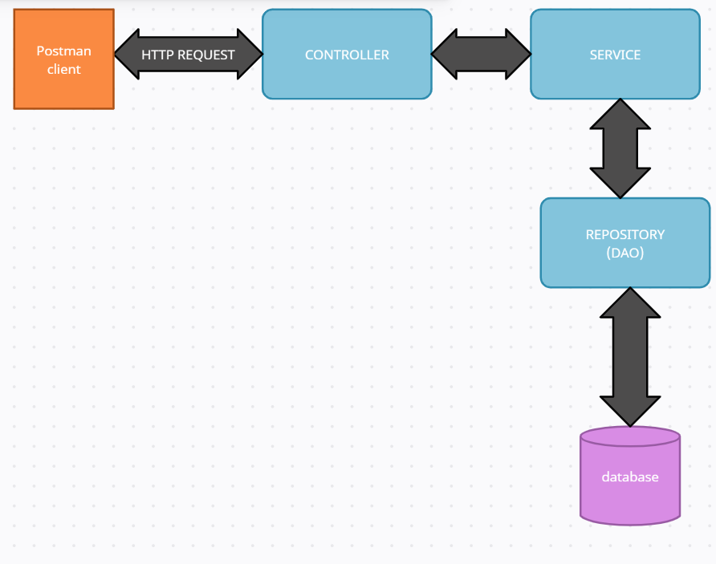

*Figure 2‑8 : Spring Boot application architecture*

### RESTful API

RESTful is an application programming interface which allows applications to communicate with each other via the Internet. Alexander S. Gillis explain more about this subject in his article [18]. It is a group of principles and constrains specially created to help and ease the work of developers. REST is the abbreviations from “Representational State Transfer” and is an architectural style software.

It appears as an alternative for SOAP and WSDL. Both are communication protocols between web pages and data. RESTful was developed in 90’s and brought a drastic change in what an API stands means. The first companies which used this API was eBay and Amazon. Later Flickr launched REST in 2004 and so the market grew and joined Facebook and Twitter. This API is based on 6 basic principles:

* client-server architecture: problems need to be separated and divided to be easier to solve. Thus, the components can be developed separately
* stateless: communication between server and client contains all necessary information
* cacheable: both the client and the server or any intermediary can store the data in cache.
* layered system: all RESTful components must respect the same rules to be able to communicate with each other.
* code on demand: the las principle is an optional one. Additional code can be used to extend the basic functionality of an application.

### Hibernate

Hibernate is a framework developed specially for Java which makes the connection between the tables in the database and the objects. What problem solve Hibernate? This framework came up with a solution so that Java objects could persist, as Torben Janssen in his article [20]. By persistence we mean being able to save data even after the end of the program. Such objects that can be saved even after the end of the program are called transient objects.

To connect the object world with the relational world a logic must be developed. This logic will insert the characteristics and states of the objects in the database. For this to be done, a list of rules must be imposed. These rules will be followed by anyone who comes to work on the model offered. The process of connecting the relational model to the object-oriented one can be reduced, and this procedure is called Object-Relation Mapping (ORM). After the objects was saved permanently in database, they can be picked up later and mapped back into objects.

In figure 2.9 we can see all the future of Hibernate. All are very important and useful. The image presents them very well, their names being explicit and for this reason we will not discuss each one.

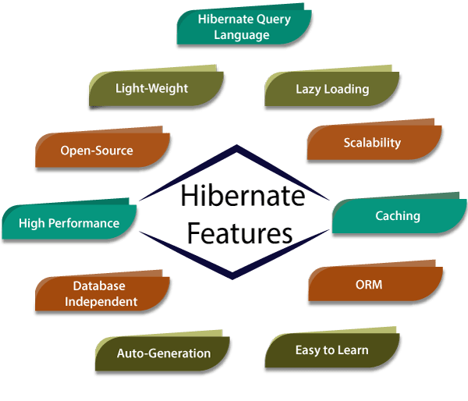

source: <https://www.tutorialandexample.com/hibernate-features>

*Figure 2‑9 : hibernate futures*

### Lombok

Lombok is a Java library whose purpose is to avoid writing duplicate code or boilerplate code. Using this future saves us a lot of time that we can lose by writing portions of code like getter or setter, even constructors. The basis of Lombok is annotations. It comes with a multitude of annotations; they can be used both jointly and individually.

As we can see in figure 2.10 Lombok offers annotations for getters, setters, contractors with all parameters, or without parameters. There is also a very common annotation that encompasses several @Data. This annotation has: @Getter, @Setter, @ToString, @EqualsAndHashCode and @RequiredArgsConstructor.

Another improvement that Lombok brings is the builder’s write-off exemption. With @Builder annotation, we have all the necessary builders for our class. This annotation can be put on a method, on a class or on a constructor. It is most often encountered on classes.

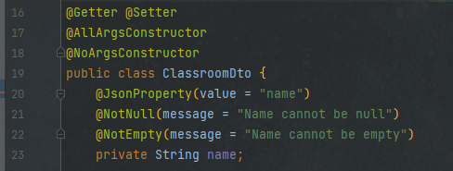

*Figure 2‑10 : lombok annotations*

### Spring Security

For authentication, authorization and protection Spring framework comes with an already integrated dependency that makes this whole process fast. This dependency is called Spring Security.

Authentication represents the user verification process. The easier example is authentication process with credentials. After a user enters the username and the password, the program must check if those are correcting and most importantly if they really exist in the database. If a username like the one entered is not found, it means that the user is an unregistered one. If the username exists, but the password was entered incorrectly, it means that the user must re-enter the password.

Authorization means the process of verifying of the permissions that a user has or not. Based on a role or a list of roles that are stored in the database, a certain type of user can make one or more requests. This step is made after the authentication process not before. As Ioram Gordadze says in article [8]: “You can think of it as an answer to the question Can a user do/read this?”. These permissions that a user’s has are called granted authority.

A simulation of how works Spring Security framework is presented in figure 2.11. From the HOME page a user accesses the LOG IN functionality. It introduces credentials, those are checked with database. If are correct the user is redirected to a new page, if not remains on the login page. After this process before any endpoint that the logged in person uploads to access it is checked if he has permission to do so or not.

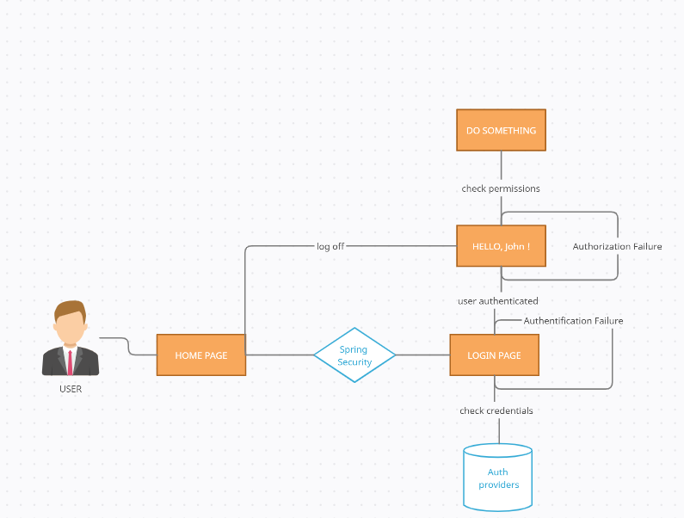

*Figure 2‑11 : example of how Sprin Security works*

Spring security also offers a very fast way to work with the data of an authenticated user. This can be done with the help of the term Principal. A principal in an Object so, if we need e specific object type is necessary to cast it. After login requirements has been successfully completed, we can retrieve the use details with just a line of code:

*SecurityContextHolder.getContext().getAuthentication(). getPrincipal().*

### Junit5

Unit testing is one of the most important parts of a complete and correct application. Testing the code that a developer writes avoids many problems that can occur during product development. The first thing avoids are bugs. If when performing unit tests for a piece of code all cases are covered, both happy cases and corner cases, the possibility of an error or bug in the application is very small.

For applications or services written in Java the most used framework for unit testing is JUnit. This framework is a free one, which can be downloaded very easily and quickly from the official website. What is necessary to know when use Junit 5 is the fact that it can be integrated just with Java 8 version or more. If maven is used in the created java project, Junit can be added very easily, just with the help of a dependency.

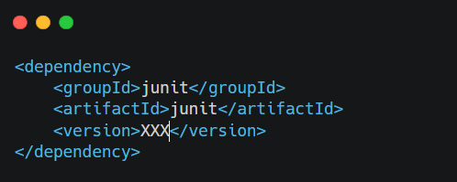

*Figure 2‑12 : jUnit dependency*

There are many advantages to using the Junit utility, the following are just a few of them:

* The quality of the code is increased because writing unit tests reduces the troubleshooting time and detects errors much faster and earlier. This makes refactoring much easier.
* Classes that contain unit tests are easy to understand and easy to write. There are many conventions that share this advantage. Some of these would be the test class must have the same name as the tested class only to add the word "Test" at the end. Each java class has a unique class and only its own for the test, for example 2 or more classes that contain business logic cannot be tested in the same class.
* Unit tests written in Junit can be tested automatically. For example, if we group them in packages and there are several test classes in one, they are run hierarchically.
* Writing test classes for the source code increases the confidence of the programmer who will use it in the written code.
* This framework is free and is written in Java, so for an application written in Java this is the best choice.

Junit 5 is a module composed from three projects. JUnit Platform which are de foundation for testing framework that runs on JVM. Also provides a console launcher which launch the platform from command line. The second project is Junit Jupiter which are a combination of extension model and new programming model. This provides a Test Engine for Junit 5. And the last project involves is Junit Vintage which provides a Test Engine for Junit 3 and Junit 4.

### Bootstrap

Bootstrap represents a free open-source development framework that helps developers to create web application and sites. It is for front end part of an application. This framework is built on HTML, CSS, and JavaScript. With its help an application can easily become responsive, such an example is shown in figure 2.13. It is very important that an application to be responsive because it can be used on several devices of different sizes and shapes. How it works? A responsive site detects the site of the screen and automatically adapt the display to the device dimensions.

What offers Bootstrap? The most important components of it are the layout components. The basic one is called container and all the other elements are inside it. The basic component offers developers two types of containers: one with fixed width and another with fluid width. Regardless of the device running an application that used bootstrap, it adapts quickly, and this is the main purpose of the framework.

The last version of Bootstrap is 5, who had the release on May 5, 2021. This new version came with the following enhancements: improved grid system, improve documentation, improve forms templates, add new responsive forms and one new API available. From Bootstrap 5 onwards Internet Explorer 11 and down is not supported. Another important update is the fact that now Bootstrap use JavaScript Vanilla instead of jQuery. jQuery represents a JavaScript library, is easy to learn but it greatly hindered the possibility of expansion.

Why to use Bootstrap? First, it split the web page in 12 columns with equals percentage values. So, in this way it is much easier to create boxes in which you can put the necessary elements to make the frontend part. Such type of box is called div. Even though at first all the sites created with this framework may seem alike, it is very flexible. Responsive classes can be controlled by device width.

Second, is very easy to install Bootstrap. Just download the source from the official page, and then in the html file you must enter the scripts that makes the connection to the libraries offered. After unloading the downloaded folder, three files will be found: CSS, fronts, and JS. The file bootstrap.min.css will be put in the CSS folder for de project and bootstrap.min.js file in JS folder.

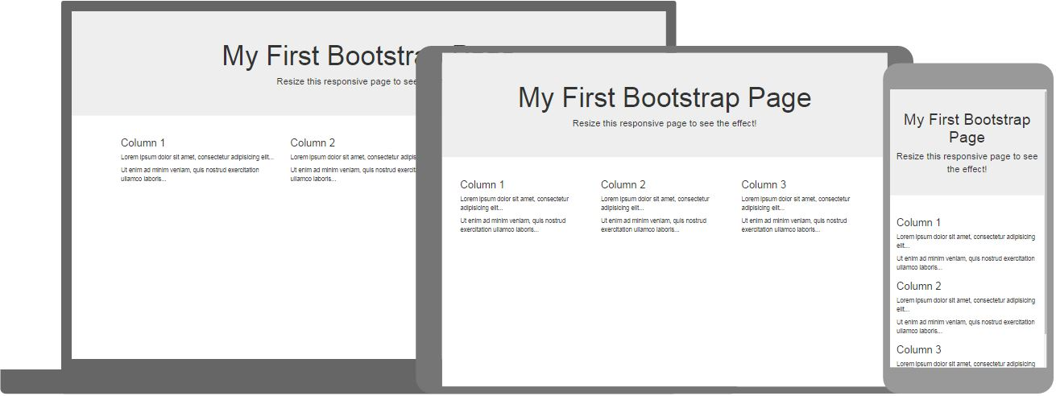

*source:* [*https://www.w3schools.com/whatis/whatis_bootstrap.asp*](https://www.w3schools.com/whatis/whatis_bootstrap.asp)

*Figure 2‑13 : Responsive web application with Bootstrap*

## Database

Database can be defined as a place where we can store data but considering the huge amount of digital data that is being processed every day, a database is not used just to store data. From beginning of the time people collect date in different ways. Because the data needs to be manipulated and uses many times it took a digital evolution.

Many databases start to grow from a simple list or spreadsheet. An example of "databases" that is widely used in many areas, not only in IT, is a data structure created in Excel. Maybe MySQL or Oracle only work in programming, but Excel is a program that we learn from high school. Such a list can store any type of information, from names to numbers, numbers and even calendar data.

If the list becomes very large, the data no longer has a specific logic, it becomes redundant and becomes very difficult to follow. In addition, in a very large list, it is very difficult to find or extract a specific element. The solution to resolve such problems is to use a database created with the help of a database management system.

DBMS are systems which help people to run queries and made operations like retrieve and store on data. An example that highlights a database management system is shown in Figure 2.14. With other words a database management system is a connection between user and database because it allows CRUD operations.

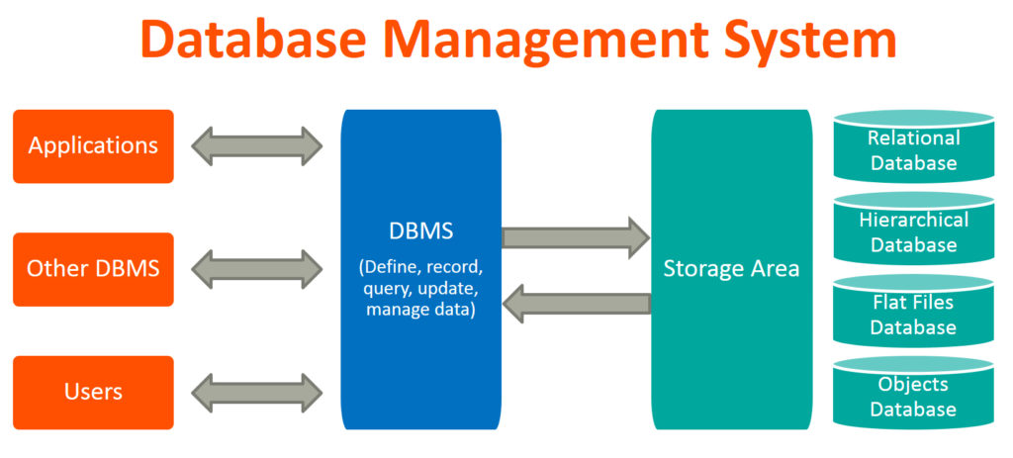

source: <https://www.facebook.com/DBMSDatabaseManagementSystem/>

*Figure 2‑14 : Database Management System flow*

Now we will discuss about CRUD operations. As can be seen in Figure 2.15 CRUD is the abbreviation for the 4 operations that can be performed on a database. Thus, we can very easily (C): create a new object in the database, (R): read a query from the database, (U): to update existing data or (D): to delete some of the data.

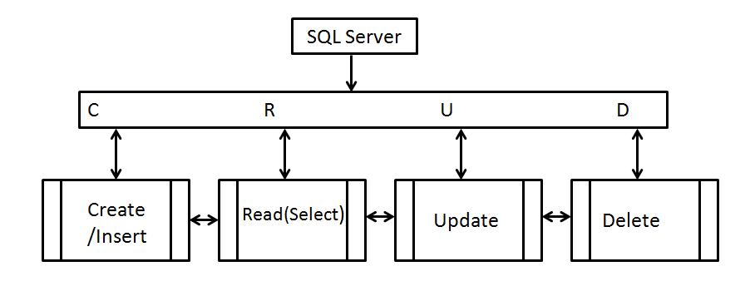

*source:* [*https://www.sqlshack.com/crud-operations-in-sql-server/*](https://www.sqlshack.com/crud-operations-in-sql-server/)

*Figure 2‑15 : Create/Read/Update/Delete operations on database*

Now that we have done the database entry, we can correlate the CRUD operations with the HTTP verbs we discussed earlier. For create operation we have the POST verb, for read/select we have GET, for Update we have PUT and for delete we have DELETE verb. In this way the work with HTTP requests and databases is much easier, because exists already a connection between them.

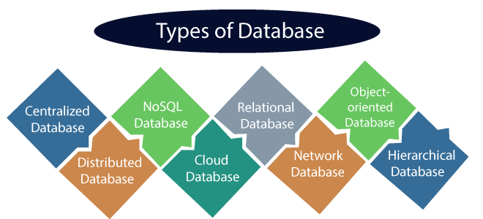

source: <https://www.javatpoint.com/types-of-databases>

*Figure 2‑16 : types of databases*

Exists many database types as can be seen in figure 2.16. Next some of popular ones will pe describe:

* DISTRIBUTED DATABASE: the data is not just in a system, are distributed different database system on a client. Connection between systems is made by links. Those links help the programmer to access data easily. An example of this type is Apache Cassandra.
* RELATION DATABASE (SQL Database): this type of database is the most common because the data are distributed in tables. Such a table, called relation, contains rows and columns. One row is called tuple and one column attribute. This relation database use SQL for manipulating data and about SQL we discussed in the language section. Some examples of this database type are MySQL, Microsoft SQL Server, and Oracle.
* NO-RELATION DATABASE (NoSQL Database): is used to store many data sets. The data are stored in different forms like document, key -> value, or wide -> column. This type of database is called “non-tabular databases”.
* OBJECT-ORIENTED DATABASE (OOD): in this database everything is an object. The data are stored with all their properties. Even if the program ends, the objects are still persistent. When the program starts next time, the data can pe retrieved as object with the properties from DB.
* CLOUD DATABASE: this is a special type because data is stored in a virtual environment. To use the database, the client needs a cloud (AWS, Science Soft, Google Clous SQL). What are the pros of this type? Cloud database is easy to access, is scalable and recovery, if something happens to the data and it were deleted or lost, they can be recovered immediately.

## Development Tools

The first time we hear about development tools, we consider that they are the applications that help to develop a project. But this is wrong, development tools are compilers, code editors, tools which helps us to make diagrams, even performance analysis tools.

### IntelliJ IDE

*Figure 2‑17 : IntelliJ IDEA logo*



IntelliJ IDEA is an integrated development environment created to work with JVM languages like Java, Kotlin, Scala and Groovy. It comes with two possible applications: Ultimate or Community Edition. Which is the difference between them? With Ultimate we can develop a full-stack web applications because it has integrated tools which offers support for JavaScript or other related technologies.

What is very interesting about this tool is the fact that has an easy start up process. Even if it is the first time when you have worked with an IDE, the process of creating a new project will take very little time. Everything is very intuitive, and all the possibilities are presented from the beginning. As we can see in figure 2.18, all the imported details are presented from the beginning: the type of project you want to carry out (android, java enterprise, java FX, Spring app), what tool you want to use for the build (Maven or Gradle) and more.

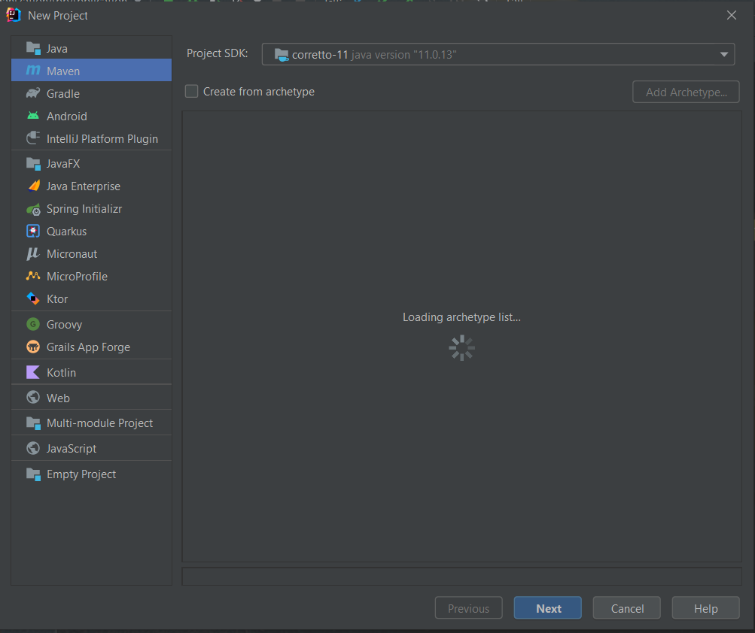

*Figure 2‑18 : create new IntelliJ project*

Another strength of this IDE is that it has many keyboard shortcuts. IntelliJ has shortcuts for just about everything. For large projects the most used from my point of view is double shift who is searching in the whole project. The second most used after writing each block of code is ctrl + alt + L which indents the source code in a predefined format. It is very important that our work to be easy to read and very clean and for this reason ident the code is a very important process.

### Maven

*Figure 2‑19 : Maven logo*



Maven is a build system. Its main purpose is both to help developers to run more easily and to manage their projects. The basis of this build system is an XML document that describes the project itself. By description we refer to the dependencies that the project needs, the version of the programming language used, the version of the compiler, etc. This document is called Project Object Model (POM).

What is very interesting is the fact that a POM module may have several children. In this case there will be a parent POM file that links to each child and a POM file for each child. A such type of document is recognized by its unique name, version, artifact id and group id. These components ensure the uniqueness of the document, because in a project no two POM files are alike.

### Postman

Postman is an application used to test HTTP requests. With other words is a tool which tests APIs. It uses a GUI where a person introduces what are the elements of the request and received different responses that need to be validated. The flow when Postman is used is the next one: a client sends a request (HTTP request) to Postman, which is a Proxy. Postman forwards the request to the server. After the request has been processed, the server returns a response to the client via Postman.

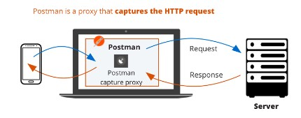

source: <https://learning.postman.com/docs/getting-started/proxy/>

*Figure 2‑20 : Client-Server connection with postman*

With Postman many types of methods can be test. For example, if we want to obtain some information, we can use a GET method. For add a new information is used POST method. If we want to delete something we can used DELETE keyword. And the last, but not the least, PUT and PATCH, which are for updated something what already exists in the database. The difference between them is the fact that PUT replace an information, while PATCH update certain information.

What is important to know when using Postman tool is that for each request sent this offer a response code. This code tells us if the request was successful or if errors occurred during it, both from the server and from the client. There are five categories of response code that can be found:

* 100: in this category are temporary responses, like 100 – Continue or 102 – Processing
* 200: here are the requests that are accepted by the client and are processed successfully by the server. Some examples can be: 200 – Ok, 201 – Created, 204 – No Content
* 300: this is a special category which is not very common, this response codes are for URL redirections. This series includes codes such as: 300 – Multiple Choices, 302 – Found
* 400: this category represents the error occurs from the client. 400 – Bad Request, 401 – Unauthorized, 403 – Forbidden
* 500: this category represents the error occurs from the server. 500 – Internal Server Error, 501 – Not Implemented

### Creately

*Figure 2‑21 : Creately logo*



Creately is a tool used to create diagrams and design capabilities. It is a software as a service created by Cinergix. It is a cloud base diagram tool built on Adobe’s Flex/Flash technologies and provides a visual communication platform for visual teams. It can be used to create UML diagrams, flowcharts, Gantt charts, organizational charts, website wireframes and many other diagram types.

Their main product is an online edition with support for all modern web browsers like Firefox, Chrome, Safari, and Opera. But exist a second version which is a downloadable edition for those who prefer an offline option. This version is compatible with Windows, Mac, and Linux.

### Draw.io

*Figure 2‑22 : draw.io logo*



Like Creately draw.io is a free tool for creating graph drawing. It is developed in HTML 5 and JavaScript and is an open-source platform. It is available both online version and offline desktop application for Linux, macOS and Windows. This tool is integrated with cloud services and in this way all the diagrams we make can be saved directly on Dropbox, OneDrive, GitHub, or Google Drive.

We can create many types of diagrams. Some examples can be flowcharts, wireframes, and UML diagrams. It is very intuitive and easy to use. All the items we need are on the left grouped by category to make them easier to find. It also adds design by providing a multitude of colors and fronts for both the shapes we use and the text.

### MySQL Workbench

*Figure 2‑23 : MySQL logo*



MySQL Workbench is tool for creating and visualization the database model and design. It is used just for MySQL server, as the name implies. It is not useful for other types of databases. With other words this tool provides an interface with the help of which it possible to work much easier and in a structured way with relational databases.

It supports to crate multiple models for different databases in the same environment. This is a strength for companies or developers working on multiple projects at the same time. Furthermore, MySQL Workbench has a build integrated, so in this way if an issue appeared in reported immediately. This tool supports all operations that can be made on a relational database like the basic one crate tables or views, to the most complicated: procedures and triggers.

# APPLICATION DEVELOPMENT PROCESS

## Expected Impact and Functional Requirements

### How Impact This Application Real Word?

We live in the age of technology and for this reason everything is evolving very fast, and we must keep up with the evolution regardless of age. Nowadays almost everything we need is a click away and for this reason came the idea of ​​building an application that will whistle both students and teachers.

“Intelligent system for orientation and flexible organization of student and teacher schedule “started from the idea of ​​helping new students to orient themselves more easily in the faculty. We were all 1st year students, and we know how hard it is to adjust and find the classroom in the first weeks of college. In order not to be just a temporary application, to look at after the first 2-3 months of college, we decided to bring a plus and this to have a special functionality for teachers.

So, it comes to the aid of teachers with an option by which they can add a new activity for a certain type of course. By activity we mean a laboratory, a course or maybe a seminar. To do this the user is asked to fill in a form with certain data such as: the name of the course to which the activity belongs, the day of the week in which it takes place, start hour, end hour, the teacher who will support the activity and the type of classroom required.

After completing this process, just by pressing a simple button the teacher will receive a list of classes available at the time interval and the day entered by him for the new activity. Then just choose a class from the list shown. And that makes the work of teachers easier when it comes to choosing classrooms

The implemented algorithm considers both the type of room required, the time slot entered, and the number of students in the chosen group or subgroup. So even if it is an application for universities, I consider that it comes with a plus, both in the help of students and teachers. There is no such application in our university, and I think it would be very useful. Many teachers would like to use it, making their work easier and reducing the time to manually search for a free class where they can support their classes.

The application is a web-application in this moment, but we want to group up fust and maybe in the future we will develop a mobile version. As we can see in everyday life, the phone is the device that is not missing from anyone's hand.

### Functional Requirements

This application has three types of users: STUDENT, TEACHER, and ADMIN. At this point, as the application is designed, each user can have only one role. Each user can log in using the institutional email which is unique and a password that was automatically generated and received when they insisted on their role. The login functionality is the same for everyone. In the back, the algorithm checks the role of the user who wants to authenticate and based on that he knows which main page to open.

Now we will present each requirement in detail, but not from technical point of view, just what and how can do each user.

1. LOG IN REQUIREMENT: because this functionality is common, we will discuss it separately. To login a user must introduce institutional email and password. If one of them are incorrect the user will receive an error: “Your credentials are incorrect”. If the email does not exist in the database a special message appears: “You do not have access to log in this application. “.

* After the user login he/she will be redirected to the main page, HOME PAGE, where will see all the options that he/she has depends on his role.

1. STUDENT REQUIREMENTS: a user who has the student role can search a certain classroom, view your own schedule, view profile, and edit some information from profile.

* To search a classroom a student just introduces the classroom name and as response he will receive details like floor, faculty and area about it and a picture with the floor where the search class is located. If he introduces a wrong name an error will occur.
* To view her/his schedule is enough to go on SCHEDULE option and it will appear. A schedule for the entire working week will appear indicating when and where each activity takes place.
* Each user can see their own profile with all personal data. Some of them can be edited but not all. Because for example the CNP, or the email cannot be updated by the student, or some can never be changed.

1. TEACHER REQUIREMENTS: in addition to the functionalities that are common with those that a student can do: search classroom, view schedule, view and edit profile, a TEACHER user can add a new activity for the courses where he/she is coordinator.

* to add a new activity the teacher must introduce some requirement fields and specify what type of classroom needs for this activity. After he introduce those details a list with classes that are free on the day and time interval entered will appear. After he chose a classroom, this will be reserved especially for the created activity.

1. ADMIN REQUIREMENTS: beside the login and view/edit profile functionalities which are commons for all users, an admin can made CRUD operations on students, teachers, classrooms or activities, no matter what course this activity takes.

* On student entities the admin can add a new student, to do that he will introduce some mandatory information. After that a password will pe generated for the user and will be saved in database. Furthermore, the admin can delete or edit information about any student every time.
* The same operations that can be made on the students, the admin can do on teacher entity. So, he can delete a teacher, add a new one or edit information from database. As with editing your own profile, not all data can be updated. For example, CNP cannot be changed never.
* The admin is the only one which can add a new classroom with all necessary information and with a picture. The picture will be that of the floor where the class is located, and it will be marked.
* Furthermore, the admin can add a new activity no matter what course it belongs to. What is different from the functionality for the teacher, the admin must introduce the coordinator name, the course name for which it adds new activity and the name of the reserved classroom. He has not the option to find the free classrooms from university.

### Non-Functional Requirements

So far, we have only discussed about functional requirements, tools, and programming language that we use to create the application. But there is another category of functionality without which applications in general could not be used: non-functional requirements.

Non-functional requirement, as Indeed Editorial team says in article [19]: “is an attribute that dictates how a system operates. It makes applications or software run more efficiently and illustrates the system's quality.”

In the figure 3-1 we can see a diagram with some of the importance non-functional requirements for a web application. There are a lot of non-functionality requirements, but we will present just some of them:

* SPEED: A good connection to internet so that the application does not run-in frames. A good and fast response to the commands
* SECURITY: same date must be protected. For example, password generation, or security questions.
* PORTABILITY: the product must work very well regardless of the system it is running on
* USABILITY: the users must be capable to use certain features.

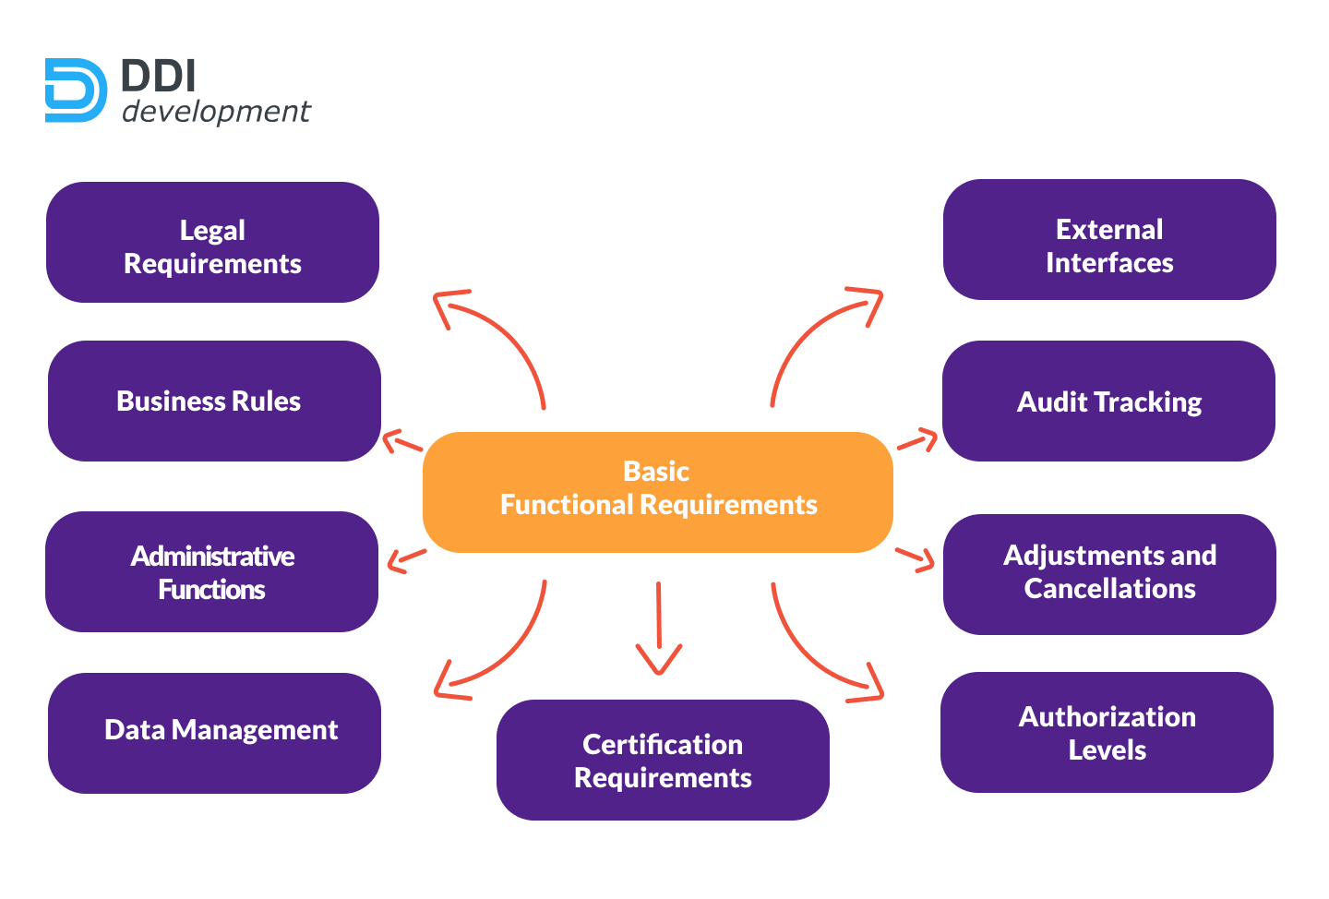

source: <https://ddi-dev.com/blog/programming/functional-vs-non-functional-requirements-what-is-the-difference-ultimate-guide-with-examples/>

Figure ‑ : non-functional requirements

## Pre-Development Steps

In this subchapter we will discuss about pre-development steps. What this means? All diagrams that a developer need before starting a project. We already have experience with such things because in the faculty we work on two subjects, Software Engineering and Project III Tools for Program Development, where we learned about how create such diagrams.

Behind the investigation related to the budget, the manpower needed, the time required to develop such a process just like pre-development steps are making these diagrams. The easiest way and maybe the most recommended way to develop an application is by taking as a start point several diversified diagrams and tables.

Theoretically, these documents are made by the architect or by the client, but every developer needs to know how to do it to understand the requirements that are brought to his attention. To build all these documents, follow some steps that are learned by everyone. That is, to create any diagram we must follow the conventions. We cannot combine elements from one diagram to another so as not to confuse things.

Performing all these steps before starting the actual development of an application saves both the client and the developers from many problems that may occur. Or if there is a problem, they at least know how to approach the situation.

### Database Model

“Orientation and Organization App” used a relation database and for this reason there is a very detailed scheme of the database. This model has the scope to present the logic structure of the database, the relationships between tables and the constrains. We will talk and describe a relation model. Exists many other types of diagrams which present a database, but this fits into what needs to be done in this project.

In figure 3.2 we will see the entire database. Because IT is very large and it is not clear what fields each table has, we will discuss them one by one. This is just an overview.

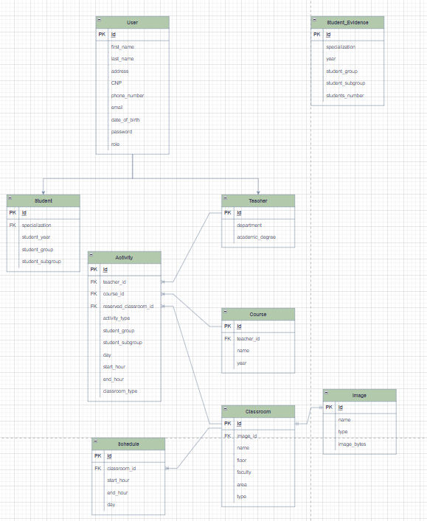

Figure ‑: database relational model

* ACTIVITY TABLE: We decided that the option for a teacher to add a new activity by answering a list of available classes will be the main one. So, the database model started to be developed from the Activity table, all other relationships appeared later as needed. Of course, this model was not developed in the first attempt, all started with a table, then added more and more tables or fields that we needed.

To be able to add the fields for this table was easy. First, this entity to exists need a start and an end hour. Second, it is mandatory to put the type of the activity (laboratory, seminary, or course). To be able to create the algorithm we talked about, the one in which we will receive as an answer a list of free classes, we need to know what type of class this activity needs.

What is mandatory to be able to create an activity is the teacher who will teach it. So, from the list with the teachers, in activity table we will have an id that indicates a specific teacher. This means that is a many-to-one relationship between Activity and Teacher. A such relationship type is between Activity and Classroom, because one activity it needs a reserved class where it can take place. The last but not the last field in this table is course_id. We need this field because an activity belongs to a certain course. By courses we mean a list of subjects, not a course-type activity.

* CLASSROOM TABLE: here things were clear. Each classroom requires a list of schedules in which it is busy, so we can check the intervals in which it is free. So, between Classroom and Schedule is a one-to-many relationship.

Because the initial idea of ​​the application was to be able to search for a certain classroom, I also added an image field in the classroom table. Thus, each class has an image, which illustrates the position of the class and provides some details to make it easier to find. When the search endpoint is accessed, this will be the response. To compute this response, we need four more fields (name, floor, faculty, and area). Faculty and area are Enums, name are a String and floor an integer. And the last added field was type because we must make a query on this table to obtain both the classes arranged at a certain moment of time, and those that have the same type as the one of the enter activity.

* SCHEDULE TABLE: this tables contains all the schedule for all the classrooms. If we only want those of a certain class, we can query the classroom_id field. In addition to this parameter, the table also contains fields such as: day, start time and end time. All these fields make up an interval in which the respective class is occupied.
* IMAGE TABLE: this table is just a helper in which we store the images for each class. We needed this to be able to later display the image when the search operation is performed.
* STUDENT_EVIDENCE TABLE: this is a table which has nothing to do with the rest, but it is one without which the student arrangement algorithm could not be implemented. This table contains the records of each group and of each student specialization, respectively. So, in this way when a new activity is introduces, we check its type, for which group / subgroup it is and from table Student_Evidence we take the number of students.

There are three tables left that we did not discuss, but they have a more special relationship and for this reason we decided to talk about them at the end (User – Student – Teacher). Between those tables are an inheritance relationship, where User is the parent and Student, and Teacher are the children. This is also visible in the following figure 3-3.

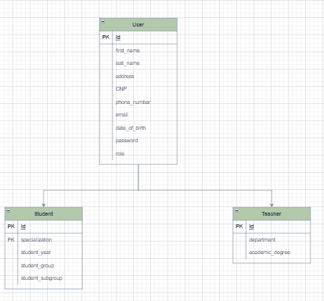

Figure ‑ : User-Student-teacher database relationship

Initially there were no three tables and one such relationship, respectively. We have just Student and Teacher tables. But because many of the fields were repeated in both, we decided to introduce a third table.

* USER TABLE: contains all the personal information about a person. This information’s are the same both for student and teacher. Many of them are Strings but exists some exceptions. Date_of_birth field are Local Date type, CNP are long type, phone number is int and role is an Enum, which can have three values: STUDENT, TEACHER, or ADMIN.
* STUDENT TABLE: in addition to the attributes, it inherits from the parent, this table also has 4 fields of its own: specialization, which is an Enums, studyYear, studentGroup and studentSubgroup. This fields are specific to a student, for example a teacher-type object will never have them.
* TEACHER TABLE: This table also has specific features for a teacher, such as the department he belongs to (software engineering, automation and electronics, mechatronics, and robotics), academic degree, a list of the courses he holds and a list of activities.

### Use Case Diagrams

“Orientation and Organization APP” has three types of users, so we will have 3 use case diagrams, one for each user. To create this diagram was used draw.io tool.

From USER we have arrows which indicates what all users can do that is to log in. Regardless of the type of user, everyone has this functionality. Then from STUDENT we have arrows to the functionalities of a student-type user. These are common to those of a PROFESSOR user. The extra functionality that is brought to a TEACHER user is to be able to add an activity.

We will discuss each functionality separately in the Requirements subchapter. Now just let’s make an overview of the use case diagrams. The admin user has total power over what happens in the application. That means it can perform all CRUD operations on each entity separately. In order not to load the diagram, I did not list each one, but I said what entities can make them.

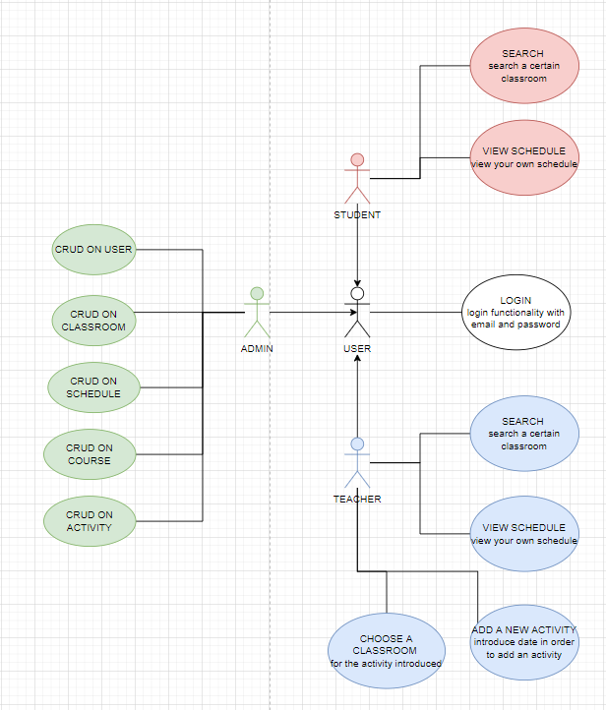

Figure ‑ : activity diagram

### Use Case Scenario

Use case Scenarios are like a “story” about what a user can do and a short description about each. Exist two types of scenarios primary and secondly. In the next section we will discuss them all, following that in 3.2.3.2 subchapter we will detail only the primary ones. But first let's list them to know what they are about:

* Primary scenarios: login, add new activity, search a certain classroom
* Secondly scenarios: view schedule, CRUD operations on classroom, schedule, course, user, activity

#### High-level

|  |  |
| --- | --- |
| **NAME** | **Login** |
| **ACTORS** | STUDENT, TEACHER, ADMIN |
| **TYPE** | Primary |
| **DESCRIPTION** | This use case starts when a user accesses the page and wants to enter |

*Table 2 : high level use case login functionality*

|  |  |
| --- | --- |
| **NAME** | **Add new activity** |
| **ACTORS** | TEACHER |
| **TYPE** | Primary |
| **DESCRIPTION** | A teacher has the option to add a new activity. As a response he will receive a list of free classrooms and to finish the procedure must choose an option from that list |

*Table 3 : high level use case teacher -add new activity functionality*

|  |  |
| --- | --- |
| **NAME** | **Search a certain classroom** |
| **ACTORS** | TEACHER, STUDENT |
| **TYPE** | Primary |
| **DESCRIPTION** | Both teachers and students can search a certain classroom just introducing the name of it. |

*Table 4 : high level use case search classroom functionality*

|  |  |
| --- | --- |
| **NAME** | **View schedule** |
| **ACTORS** | STUDENT, TEACHER |
| **TYPE** | Secondly |
| **DESCRIPTION** | This use case is for both types of users. To do this a student, or a teacher just choose the SCHEDULE functionality. |

*Table 5:high level use case view schedule functionality*

|  |  |
| --- | --- |
| **NAME** | **CRUD operations on USER entity** |
| **ACTORS** | ADMIN |
| **TYPE** | Secondly |
| **DESCRIPTION** | An ADMIN can create, update, read or delete a certain user. |

*Table 6:high level use case admin-CRUD on USER functionality*

|  |  |
| --- | --- |
| **NAME** | **CRUD operations on CLASSROOM entity** |
| **ACTORS** | ADMIN |
| **TYPE** | Secondly |
| **DESCRIPTION** | The same as the previous use case, an admin can do CRUD operation on classroom entity. |

*Table 7:high level use case admin-CRUD on CLASSROOM functionality*

|  |  |
| --- | --- |
| **NAME** | **CRUD operations on ACTIVITY entity** |
| **ACTORS** | ADMIN |
| **TYPE** | Secondly |
| **DESCRIPTION** | Last but not the least, on ACTIVITY entity the admin can perform one of the following operations: create, read, update, or delete |

*Table 8: high level use case admin-CRUD on ACTIVITY functionality*

#### Primary Use Case Summary

In the above subchapter we discuss about all user case scenarios for our application and now we are choosing to present in the following pages the detailed course of action for our two main primary cases. These two cases are the main purpose of our application.

|  |  |
| --- | --- |
| **SEARCH A CERTAIN CLASSROOM** | |
| **Pre-condition: the user must be logged as a student or a teacher** | |
| **Post-condition: an image showing the positioning of the classroom search and some details about it where be sent as response** | |
| **ACTOR INPUT** | SYSTEM RESPONSE |
| 1. **The actor accesses the main page of the “Orientation and Organization App” by clocking the corresponding button** | 1. The system analyses the command and sends a response |
|  | 1. The main page is logged |
| 1. **The actor introduces the name of the classroom which he wants to find** |  |
|  | 1. The system makes a query in the database and searches for the class according to the name entered |
|  | 1. The system makes a query in the database and searches for the image for the found classroom. |
|  | 1. The system sends the responses to the user |
| 1. **The user will see the picture with the classroom and some helpful information** |  |
| **This scenarios end when the user presses the BACK button and is redirected to the search page again.** | |

*Table 9: primary use-case for search classroom scenario*

|  |  |
| --- | --- |
| **ADD A NEW ACTIVITY** | |
| **Pre-condition: the user must be logged as a teacher** | |
| **Post-condition: The user will receive a response such as: A NEW ACTIVITY WAS ADDED SUCCESFULLY and the details about it** | |
| **ACTOR INPUT** | **SYSTEM RESPONSE** |
| 1. **The actor accesses the ADD NEW ACTIVITY options** | 1. The system checks if he/she is a TEACHER and can access this functionality |
|  | 1. If the actor is a teacher a form will appears, if not he/she will receive a warning message. |
| 1. **If the form appears the actor must complete it with the required data** |  |
|  | 1. The system checks if all the date are correct |
|  | 1. The system search in database the classrooms of the type introduced and which are free at the time introduced by the actor |
|  | 1. The system sends to the actor (UI) a list with free classrooms |
| 1. **The actor chose one classroom and press save button** |  |
|  | 1. The system updates the activity entry from database with the classroom chosen by the actor |
| 1. **The actor receives as response a confirmation message** |  |
| **The scenario end when the actor is redirected to the main page of the web application.** | |

*Table 10: primary use-case for add new activity scenario*

## System architecture

The application architecture used is specific to Spring module of the Spring Framework. As we discuss in the first chapter, it contains four important layers. Spring Boot has a hierarchical structure in which each layer communicates with the next or the previous. In figure 3-5 we will see the hole architecture of this project and we will discuss in detail about each layer below.

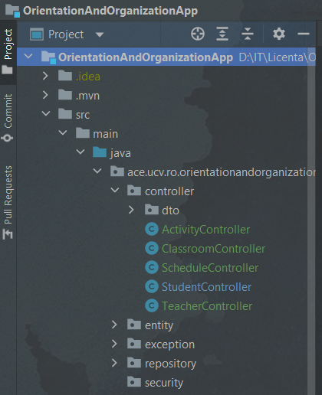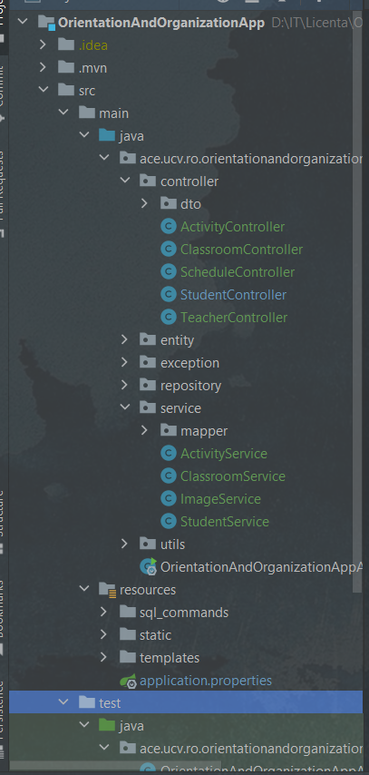

*Figure 3‑5: application architecture*

In intelliJ the order of the pachages is aphfabetical so maybe is a little hard to follow in the picture above, so I have made a new diagram that's easier to understand. As you can see in the 3-6 image, I also stayed with the four main layers only this time each contains several packagers. Now we will discuss each package and see and actually contain it.

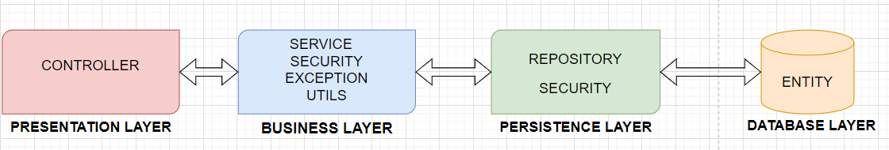

*Figure 3‑6: application architecture explicitly diagram*

### Presentation Layer

As we know from chapter 1 this layer contains the requests sent by the client. So the first package from this layer in this application is CONTROLLER PACHAKE. Here we will find classes for each entities which contains the endpoinst for operations that a user can perform. Those classes are annotated with @RestController annotation.So, in this way the compiler knows we have a controller bean. Furthermore, also in this layer and respectivly under the controller package we will find dto pachage. This will contains the Data Transfer Objects. Because we as developers do not want a user to see our entities, these DTOs were creates which gives us the oportunity to expose only the fields we want. So, we other words this pachakge contains the models that a user sees on the UI.

As an example we can take the User entity. In figure 3-7 we have the database entity for User object and in figure 3-8 we have the DTO for login. When a user login into our application is not necessary to introduce the hole fields from database, and from this reason exists DTOs. We will expose just the credentials for the user.

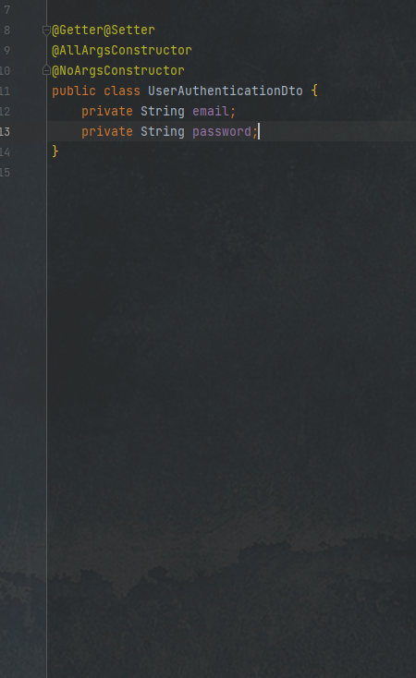

*Figure 3‑7: user authentication dto*

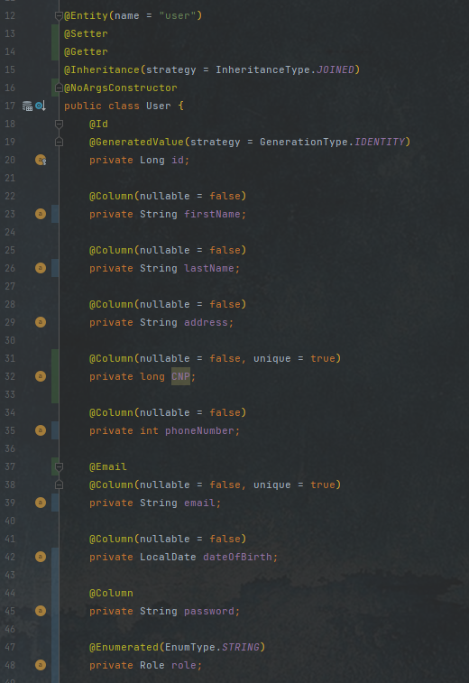

*Figure 3‑8: user entity*

### Business Layer

This layer contains all the business logic. From the validation part, until the final call method to the repository. Here we have the @Service classes, this annotation is very useful, because we no longer must make the settings for beans by the hand. With @Service annotation java compiler knows this class is a component and he will treat it like a bean.

So, as we discuss in this service classes, we have all logic for the application. Because the user sees a certain model for an entity, and behind we are working with another model we must map them. This is also done in the business layer; under the service package we have another one with mapper. Here we can map both data transfer object to entity(model) and model(entity) to data DTO.

Furthermore, also in this layer takes place the part of authentication, authorization, and validation of data. We discuss about authentication and authorization in Chapter 1, but we will make a small reminder.

* Authentication is about user credentials. Here we check if the user introduces correct his password and username. First it is checked if there is an account for such a user, and then if the data entered is correct.
* Authorization is about what a user is allowed to do and what not. For example, in our application a STUDENT cannot add a new activity, but a TEACHER can.
* Validation is about the correctness of the data entered, both when logging in and browsing. For example, if a teacher wants to add a new activity, bur introduce incorrectly the name of the course to which it belongs, or do not enter it at all. As this field is mandatory, the user must be notified that something has not been entered correctly. Some of the verifications can also be done directly on DTOs, as can be seen in figure 3-9

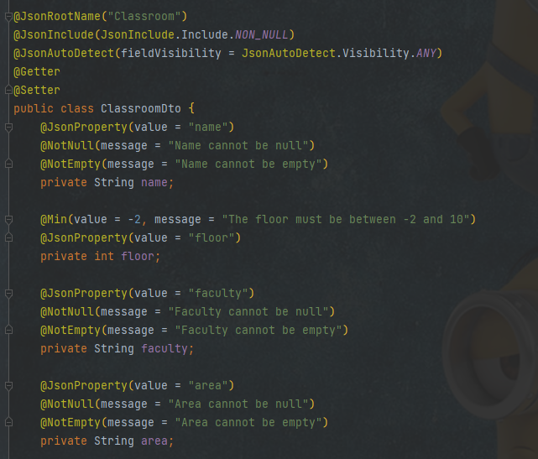

*Figure 3‑9: validations on dto*

### Persistence Layer

This layer contains the logic and translation between objects and database. Here we can define methods that allows us to access the entries from database. Because in this project we work with spring boot exist an API which help us a lot in this situation. This API is JpaRepository<>. This module of spring data which permits us to define repository bean. The repository classes are interface, because they only contain the signature of a method, not the logic behind it and are annotated with @repository annotation. A such example is in figure 3-10.

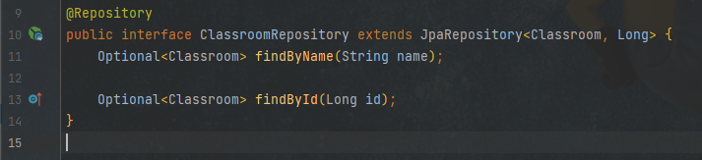

*Figure 3‑10: repository example*

Also, in this figure we can see that ClassromRepository interface extends JpaRepository<> with two parameters: the first one is a reference to the entity and the second one is the type of the ID for this entity. JpaRepository is a java persistent API created especially for repositories. With it helps we can do basic CRUD operations, but not only. In addition, it comes with another API that helps us to perform pagination and sorting operations.

Thus, we know that this repository deals with the operations that take place on the table in the database intended for type Classroom entity. What is very interesting when we used JpaRepository and very helpful is the fact that we can have method for almost anything without us implementing them. For example, as we can see in the figure 3-11, we can create a query to find us a user or a list of users, whose address contains the city of Craiova. This can also be combined. With other words, JpaRepository offers all the possible queries for an entity.

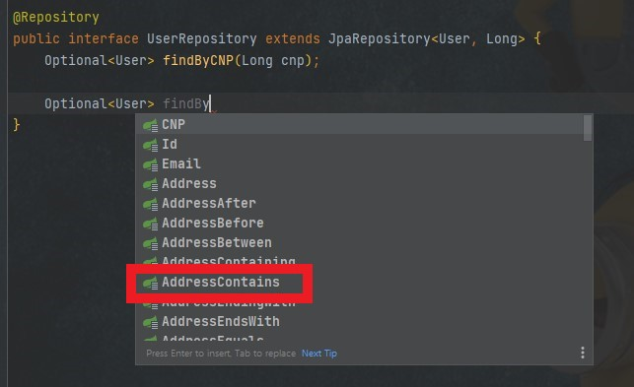

*Figure 3‑11: user repository query example*

### Database Layer

In persistence layer we talk about queries and how thei are made with jparepository help, but there is only the "front-end" part, the crud operations themselves are performed in the database layer. More precisely, this layer is strictly the database that a developer decides to use in creating his project. It is not a very big one and for this reason there is not much to say, but it is a layer without which the application would not have life.

An example of flow arhitecture is represents in the next figure 3-12. How this whole process works? Everything is very simple and there is a connection between these layers so everything has a well defined logic. A client sends an HTTP request to the server, this is received by the controller. The controller processes the request and sends it to the logical business layer, means to the service. It performs all the logic and does all the "necessary calculations" calling the repository layer if it needs a database query. The repository layer uses the database layer to perform the necessary raw operations and sends a response to the service. The service processes the response receivedends the request sent by the controller and sends a response back. The controller sends the response received from the service to the client, ie to the browser.

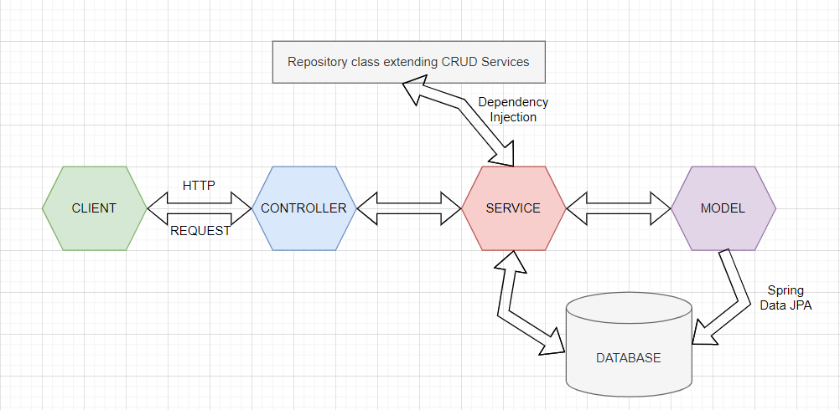

*Figure 3‑12: flow architecture*

## Implementation of Requirements

Requirements represent all the functionality offer by the application. Some of them are the same for multiple users, but there are some that are individual per user. As we discussed earlier exits three types of users: STUDENT, TEACHER and ADMIN. Exist just one admin account and no more can be created. On the other hand, a user may have only one or more roles (just student, just teacher or student and teacher). The application was designed in such a way that it could be available later for those in the master's and doctorate degree.

Now we will discuss about each type of user, and we will see what possibilities offers the developed application. As a small recap, for backend we used Java 8, hibernate, JPA repository, Lombok, RESTful API, and MySQL for database and for frontend we used HTML, Bootstrap 5, JavaScript and Thymeleaf to create the connection between them.

### Login Functionality

The login functionality is the first one and the most important. All users, regardless of their role, must be able to log in to reach the main page. The login process is made with email and password received from the faculty. As we discussed earlier, to have an obvious class and not to allow anyone to create an account in our application, initially, users log in with the credentials provided by the faculty when they become students or teachers.

In figure 3-13 is presented the LOG IN page. We can see the credentials which the user must enter. The verification is done in the background, both in terms of the correctness of the credentials and in terms of the existence of the account. After the user introduce the correct date and press Login button, he/she will pe redirected to the main page.

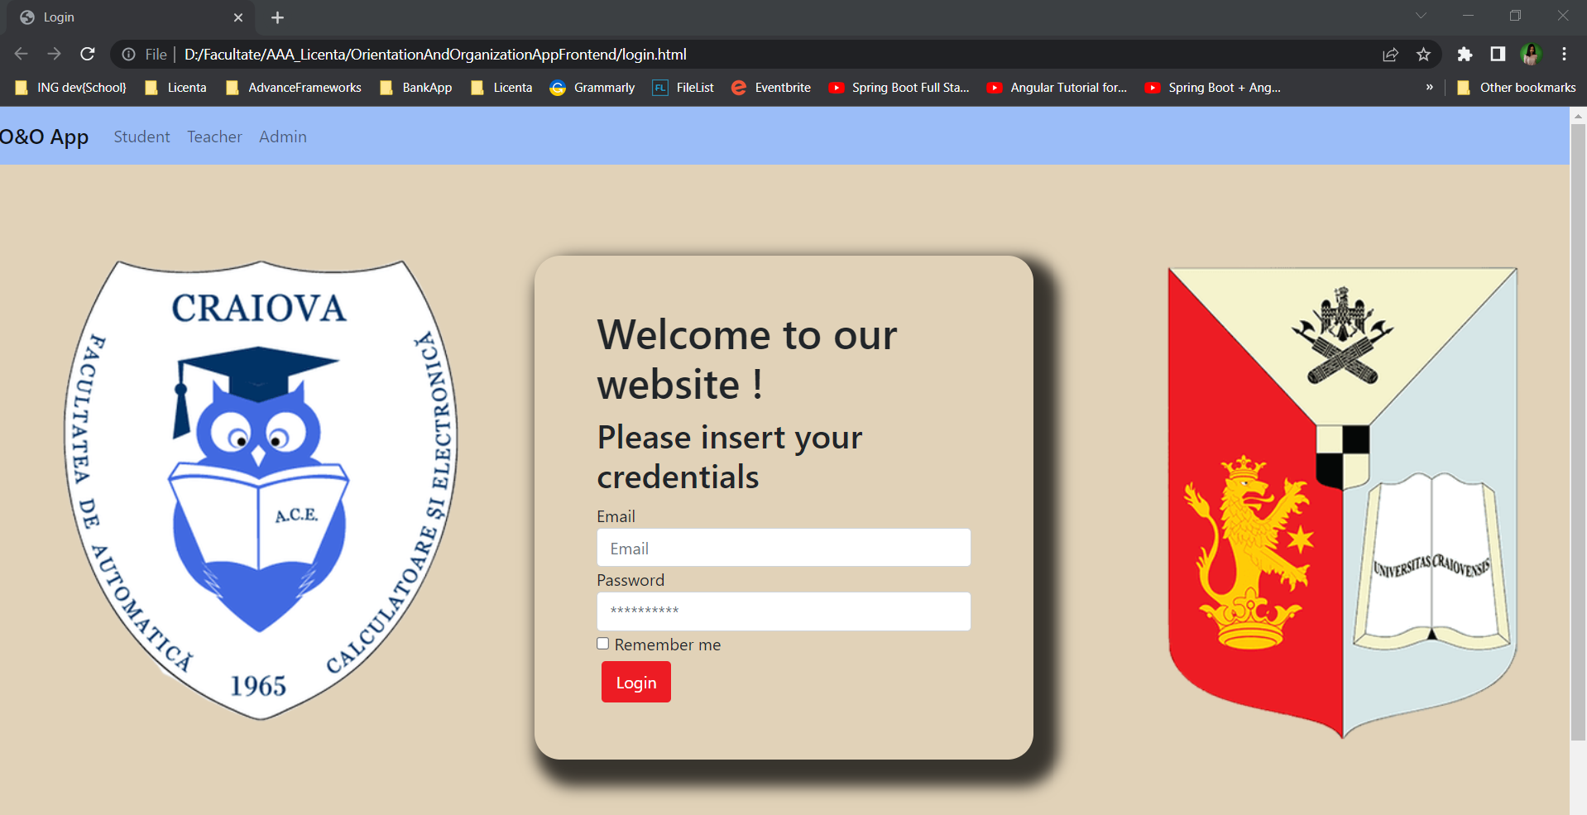

Figure ‑: login page

From backend point of view, in this moment everything is easy. The login process is an endpoint which received a UserLoginDto as body and after the verification of the credential is generated a token. With this token we can continue the login process so we can test the other endpoints. We will discuss about security and how to verify credentials are done in the Security chapter.

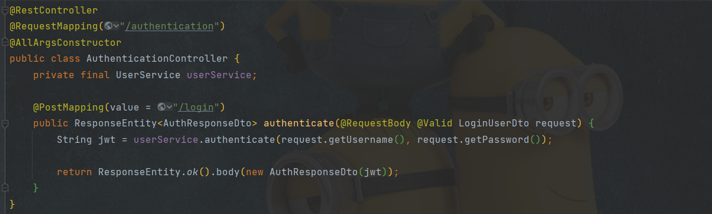

Figure ‑: login endpoint

### Student Functionalities Implementation

In the next figure 3-15 we will see all functionalities which a student has. We will discuss about each one separately. Here we can see the three options this user has: search classroom, view schedule and account.

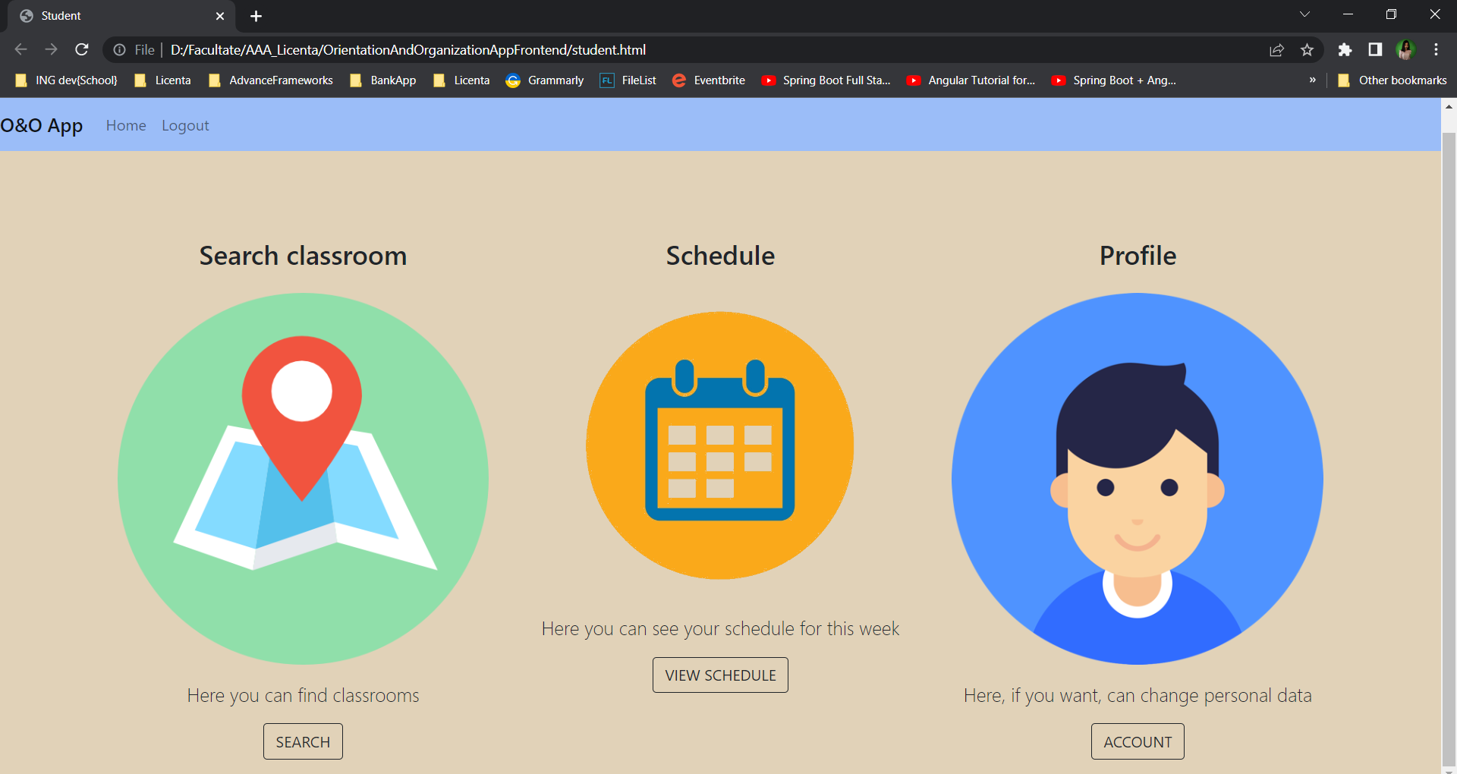

*Figure 3‑15: student home page*

Search classroom option is the most important for this type of user. If we press the SEARCH button, we will be redirected to a new page (see figure 3-16) where we can search a certain classroom. Furthermore, also on this page we have an overview of the entire faculty.

The algorithm is the next one: to be able to access this requirement the user must be logging. From the main page the student must choose the SEARCH CLASSROOM option and after that a new page will appear.

* On this page will be a search bar where the student can enter the name of a classroom.
* If this classroom exists, the system will send as response an image and some details about it. The image will have the desired class marked and the details will be such as: floor, faculty, area.
* If the name of the classroom is wrong means it does not exist, and a warning message will appear for the student.

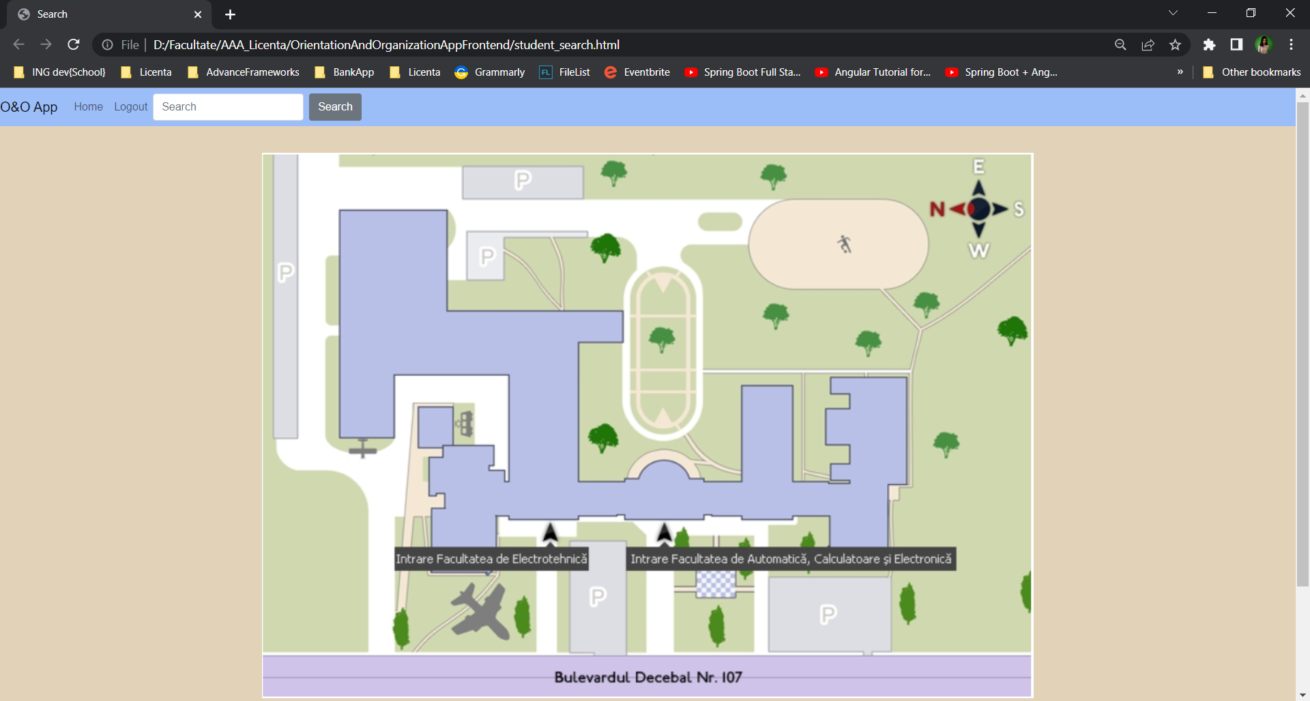

*Figure 3‑16: search functionality*

In the navbar we see the search option. Here the user can introduce a classroom name and after he or she press SEARCH button he will be redirected to a new page (figure 3-17). This page will contain an image of the floor where the searched class is located and a mark on it. In addition to this image, we are given some details about where the class can be found. Details such as: faculty, area, and floor.

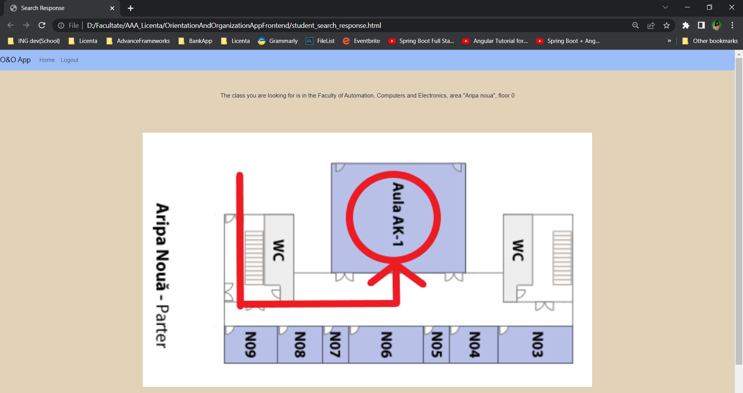

*Figure 3‑17: search functionality - response*

About the backend implementation here we used two endpoints. One for search a classroom by name and one for find an image for the certain classroom. Both are in ClassroomController class and are get methods. For endpoints, and not only, we will used Spring Boot annotations. Now let’s discuss about each method separately.

In figure 3-18 we can see the search method from ClassroomController. As we know in the controller classes, only the service classes are called. So, in this method we call the findClassroom method from ClassroomService class. To know what class we are looking for, its name is given as a variable path. And then this name is given as a parameter to the service method.

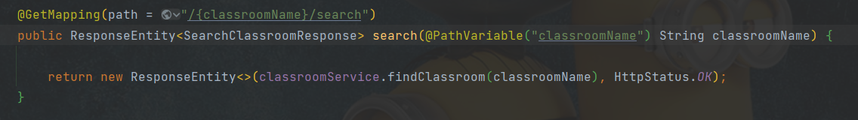

*Figure 3‑18: search functionality endpoint*

The findByName method is called for further service, which receives as a parameter the name of the searched class. This method is found in the Repository and is provided to us by JpaRepository. That is, there is no actual implementation, as seen by us. Everything happens in the back.

This process is seen in the next figure.

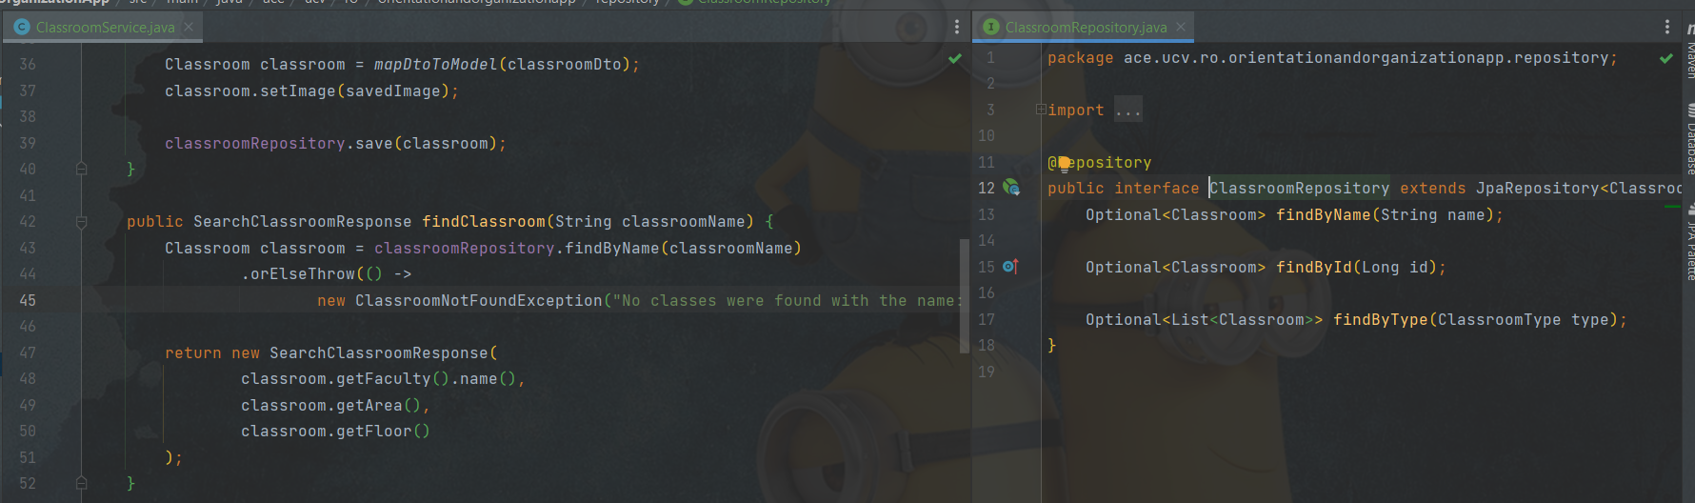

*Figure 3‑19 : search functionality implementation*

Now we will discuss about the second endpoint (figure 3-20). This is just a simple one who received as path variable the name of the classroom and search in database the image that corresponds to that certain class. In order to do an Image class was required and a utility class. The image class contains the name, the type and the bytes of the image uploaded for a ceraint class.

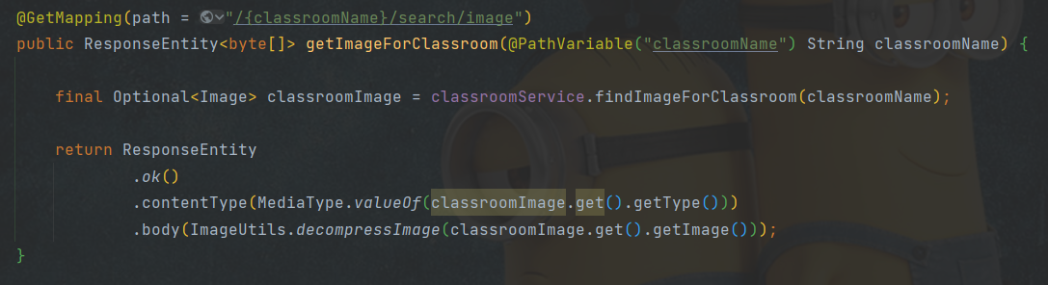

*Figure 3‑20: find image endpoint*

The ImageUtils class is, as the name suggests, a utility one. Here the image is compressed and decompressed. We need to compress an image to save in the database and decompress it when we want to view it in UI.

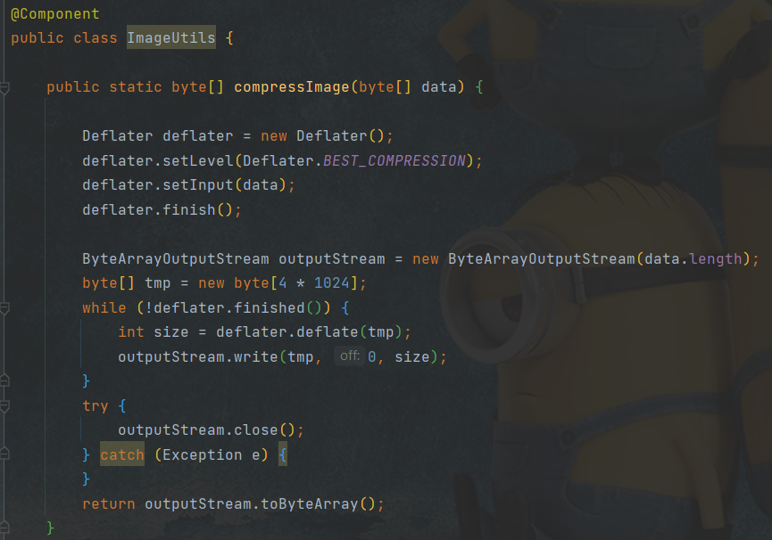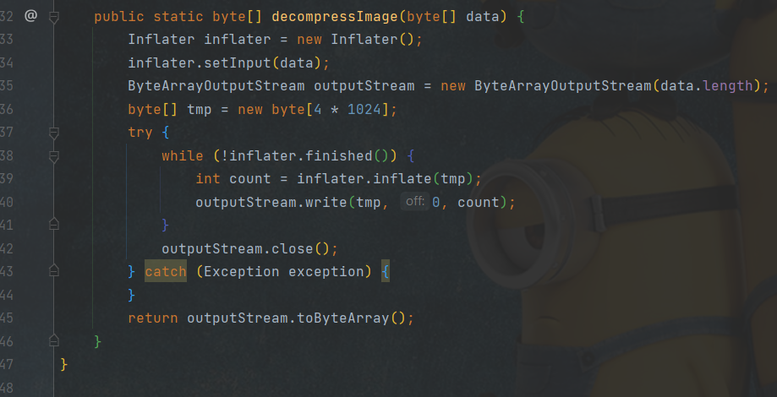

*Figure 3‑21: image utils class*

The second functionality for the student is to see theire schedule. The sechedule is for all week and shows all the courses that the user must attend. In the figure 3-22 we will see the UI for this option and next we will discuss the implementation in the backend.

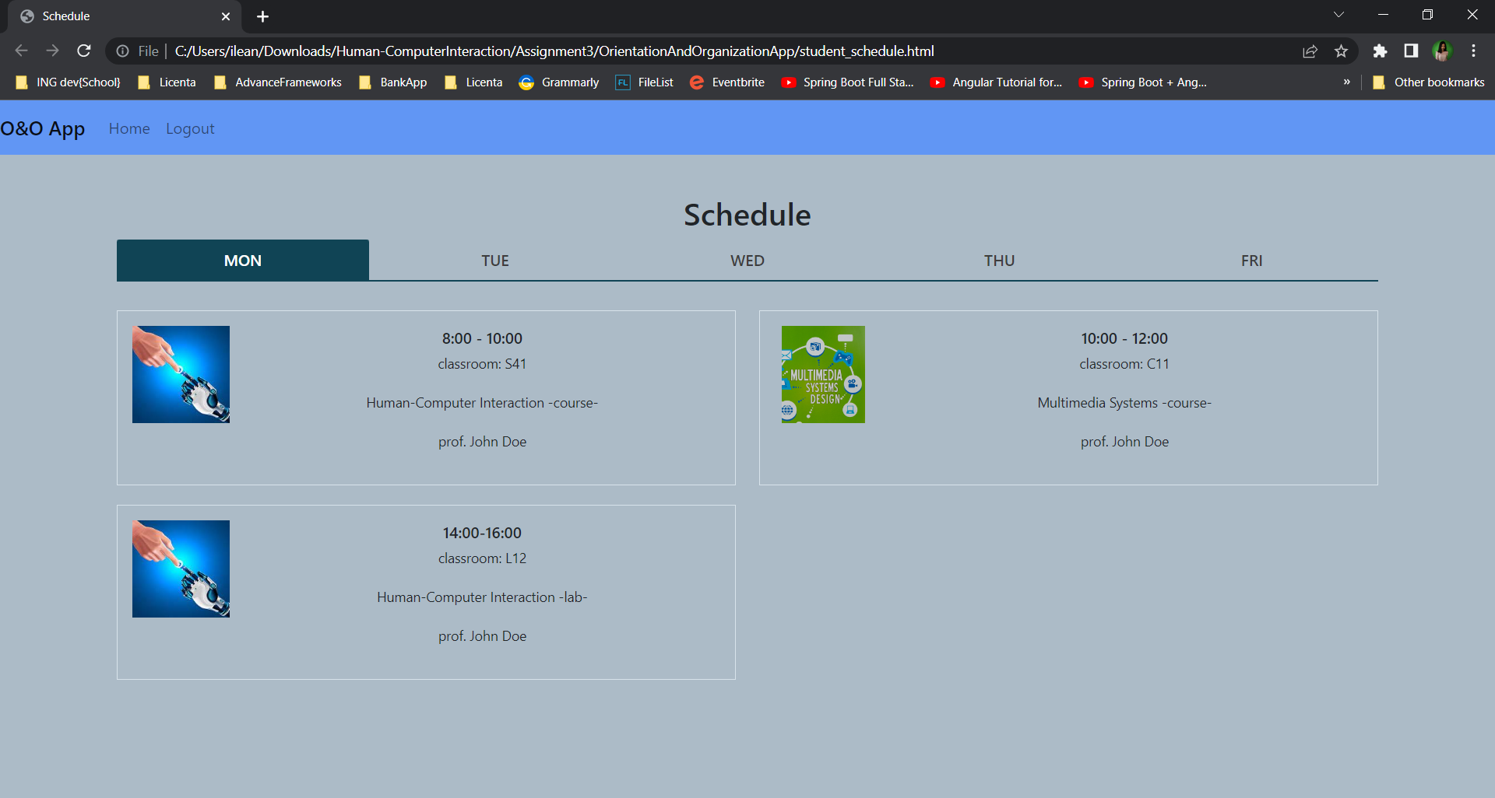

Figure ‑: Schedule functionality page

On the backend side in order to can do this functionality we need just an endpoint which reads all the activities for a certain student. This in presented in figure 3-23. In this method we call viewSchedule() method from student service. There the student in search in database about his id and then with the help of activityRepository class we find all the activities which the student has.

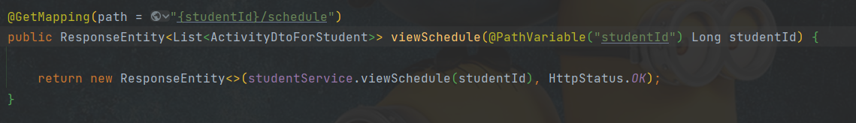

*Figure 3‑23: get schedules endpoint for students*

Because between student and activity is not a relationship, in database when we search about activities, we search all activities which are for the group and subgroup to which the student belongs.

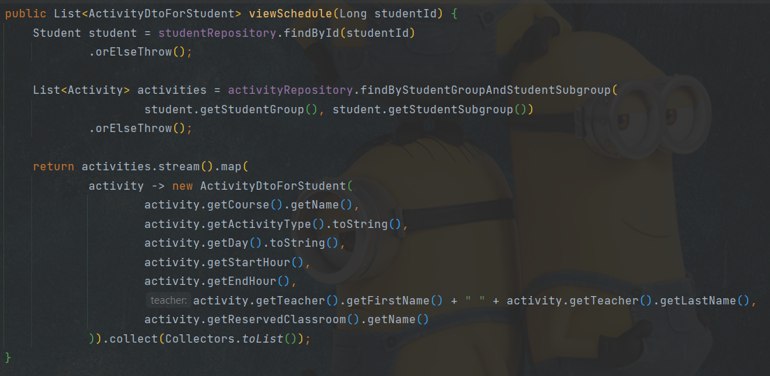

*Figure 3‑24 : view schedule function from student service*

The las functionality that a student-type user can do is to view and modify personal data. Here the student can see all the data of the persons, such as: name, surname, address, email, group, subgroup, etc. But it cannot change them all as can be seen in Figure 3-25 Only data that is subject to change, such as phone number and address, can be changed.

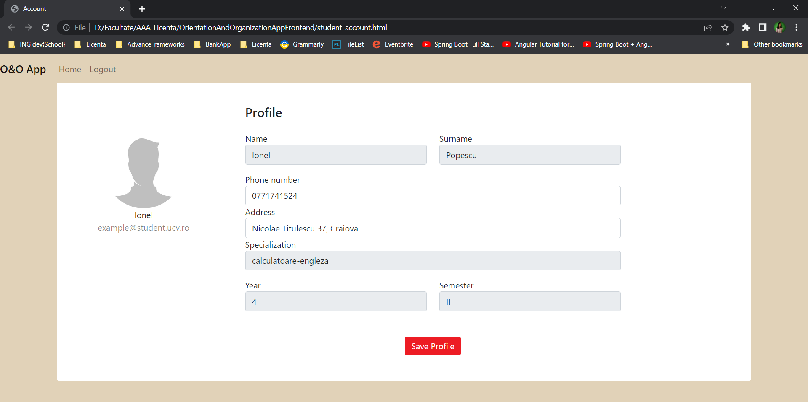

*Figure 3‑25 : Profile page for a student*

The backend implementation for this functionality is just an updated. So from the Classroom Controller class we called updatePartialy method (see Figure 3-2).

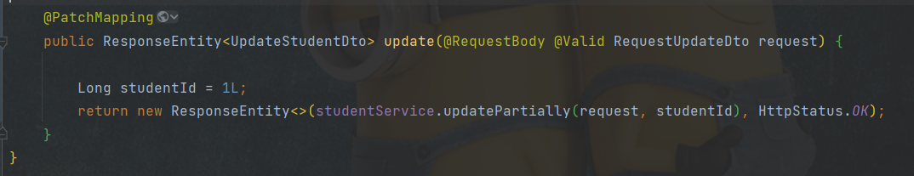

Figure ‑: update personal date endpoint - for students

As can be seen in the image above, the data update option can be categorized as a patch operation. PUT can also be used as a save operation, but it is more recommended to use the verb patch, because the update can be total or partial.

In the next figure we will see the implementation for updatePartially method from service class. This recived as paramter the student id and a request object. This object contains the field name and the field value which needs to be updated. In service class the student logged in by the id is searched in the database, and then the new fields are set, the ones that have been updated. After setting the data is saved back in the database to be updated.

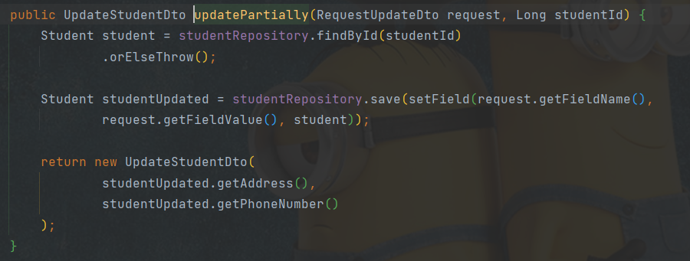

Figure ‑: implementation of update method in service

### Teacher Functionalities Implementation

The first three functionalities that a teacher user can do, the one with view schedule, search classroom and change personal date are the same as was for the student user. So, we will present just with some screenshots from front-end part and the algorithm for each option.

The algorithm for the search option for a teacher user is the next one: to be able to search a certain classroom is enough to go on the SEARCH CLASSROOM options from the main page and after that just introduce the name of the class.

* If the entered class does not have a warning message, it will be displayed to the teacher user.
* If the name entered in the search bar corresponds to the name of one of the classes in the database, the user will receive in response an image that marks the searched class and a list of details about it.
* To return to the main page, the user must press the back button in the upper right corner



*Figure 3‑28: search classroom functionality – teacher*

The view schedule option has the next algorithm: for a teacher to be able to see their own program, it is enough for it to go to the VIEW SCHEDULE option in the main menu. A table with each course at what time it is and in which room it will be displayed as an answer.



*Figure 3‑29: view schedule functionality - teacher*

And the last common functionality is the view and/or edit profile data. Here is the same problem the teacher cannot update information which does not support changes (like CNP or email).

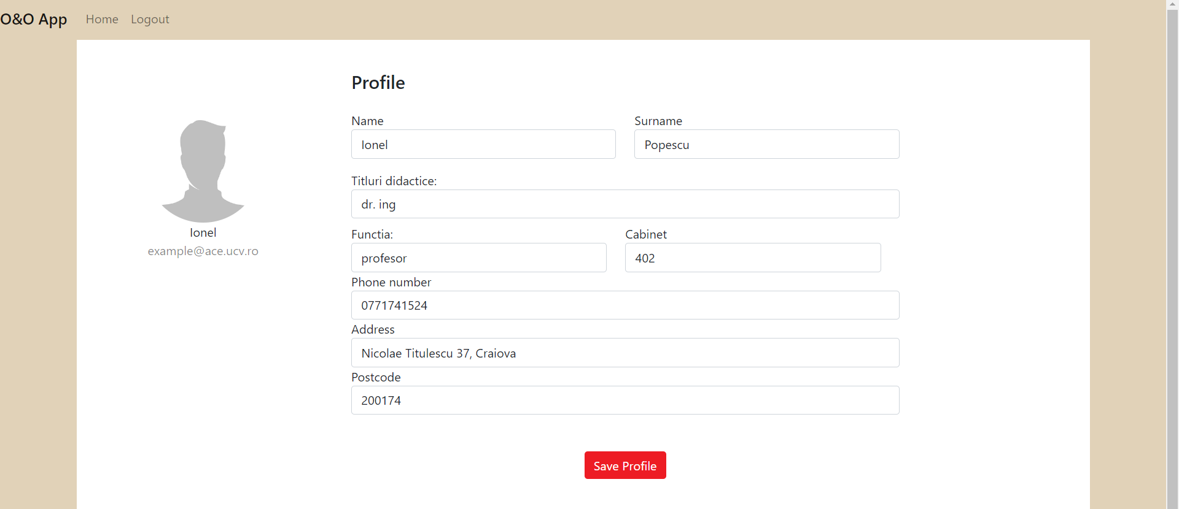

*Figure 3‑30 : edit profile functionality – teacher*

The special functionality is the one who add new activity. Here a teacher can add a new activity for the courses that he is the course coordinator. In the figure 3-31 we can see the list with all activities for a certain teacher.

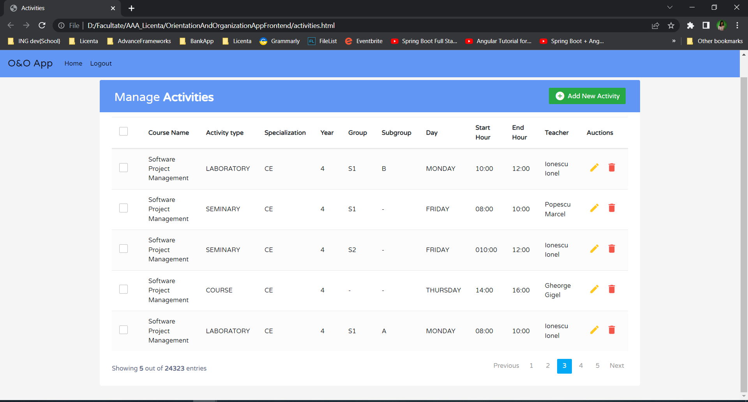

*Figure 3‑31: manager activities - teacher functionality*

We can see the fact that a certain teacher type of user can edit any activity held by one of the courses in which he is coordinator. Furthermore, he/she can add a new activity just press the “Add New Activity” button from right side. When he presses this button, a new pop-up will appear. This in presented in figure 3-32.

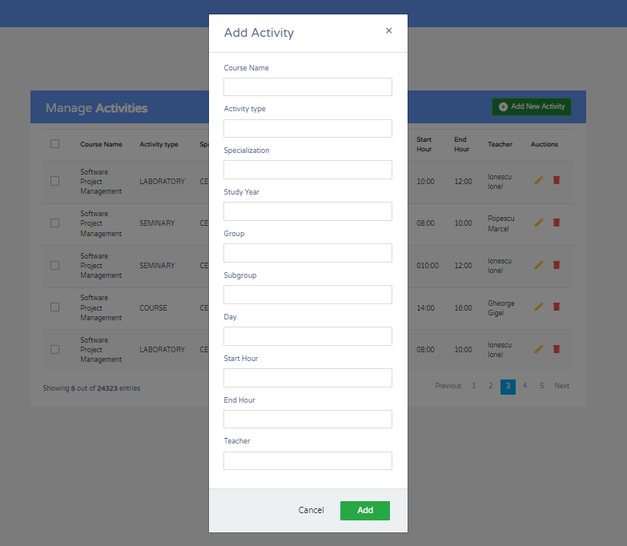

*Figure 3‑32: add new activity - teacher functionality*

From backend point of view the algorithm is the next one: the user introduces the required details about the new activity. So, in activity controller class we call the addNewActivity() method fromt activity service. In activity service class is the whole algorithm implemented.

* First step we save the activity in database without reserved classroom.
* After the new activity is saved, we search in database the list of classrooms that have the same type with the type of required classroom introduced by the teacher.
* The next step is to find the numbers of students for this activity. Here exist three possibilities:
  + if the activity is a course one, we will sum the number of each subgroup for the enter specialization
  + if the activity is a seminary one, we will sum the number of each subgroup for the group specified
  + if the activity is a laboratory one, we only take the number of students of the specified subgroup
* after we have the student’s number, we filter just classrooms that have the seats number equals or grater with the student’s number.
* On the list of free classes that correspond to the two requirements checked earlier, we look for the classes that are free on the day and the time interval entered by the teacher.

Those steps of the algorithm are presented in figure 3-33. Next, we will discuss about how we find what classrooms are free and can be occupied by the new activity.

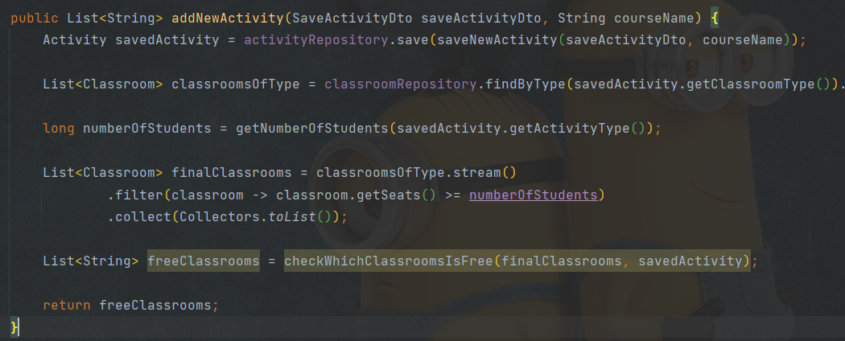

*Figure 3‑33: add new activity functionality for teacher*

Now we will discuss about how check if a classroom is free or note in the time interval entered. As he knows, each class has a list of schedules that correspond to it. Each schedule has a day, a start hour and an end hour which indicated when the classroom is busy. The idea is that we search for an interval i, check if a is equal or bigger that his end hour and then check if b id smaller or equal with the start hour of the next busy interval (position i+1)

* First, we will take from database all schedules for a certain classroom from the entered day
* Then check if the enter interval of time corresponds one of the cases created:

|  |  |
| --- | --- |
| **When is busy** | **When is free** |
| *input: [a, b), where a = start hour, and b= end hour*  *from database for example we have: List<Schedule>schedules = {i0, i1, i2}* | |
| if a is already in schedules as start hour | if a >= with end hour from i and b <= start hour from i+1 |
| if b is already in schedules as end hour |  |
| If exist i such that a >= i start hour and b<= I end hour |  |
| If exist i such that a <= i start hour and b >= I end hour |  |
| If exist i such that a <= i start hour and <= i start hour <= b <= I end hour |  |

*Table 11 : free classroom cases*

### Admin Functionalities Implementation

The admin has full access. With other words he can do everything. He can perform all CRUD operation on students, teachers, classrooms, and activities. We will discuss about each one. We will start with what he can do on the Activity entity. In the next figure we can see all those functionalities.

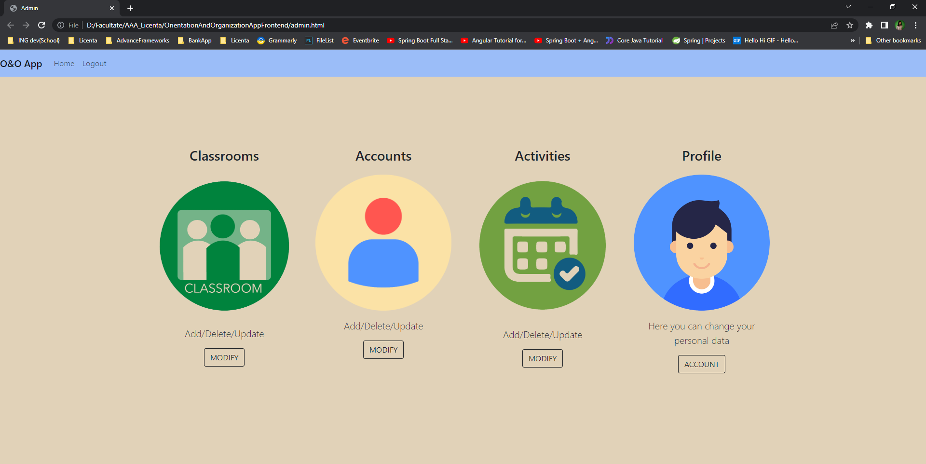

*Figure 3‑34: admin home page*

The first set of functionalities are the one for classroom entity. An admin can add a new classroom, delete the old ones or update a certain one. We can see the UI for those options in Figure 3-34.

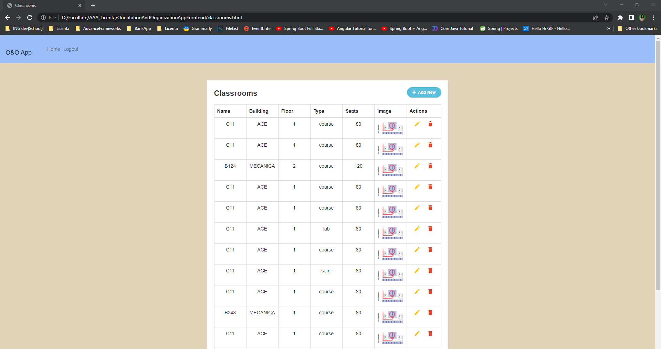

*Figure 3‑35: CRUD on classroom entity - admin functionality*

From a backend point of view, all these four options are simple endpoints. And we will take evry one separately and talk about it. First we will disucss about the endpoint which gives us all the classes as a view. This is presented in figure 3-35 and is a get mapping function.

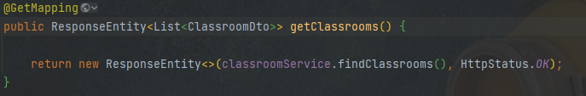

*Figure 3‑36: getClassroom() method in controller*

In getClassrooms() function we call findClassrooms() function from service. And this in turn is called the findAll() method from ActivityRepository. As I said earlier, the methods for crude oil operations are provided by JPA Repository, so we do not have to build them.

The next endpoint is the one who delete a certain classroom (see figure 3-36) To do this the name of the classroom is passed as path variable. This field is sent as a parameter to the delete method from the service and this metod called the delete method from repository. What is diferent between the one from service and this is the fact that the delete metod called on repository receives as parameter a classroom, not the name of the classroom. So before calling the method from the repository we have to look in the database for the class with the name received as a parameter in the controller. This algorithm is presented in figure 3-37

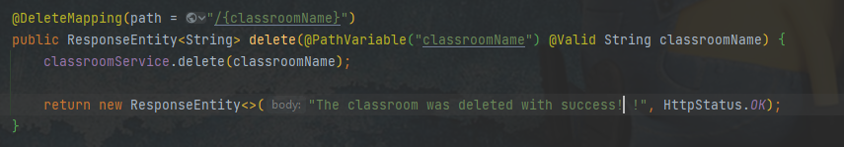

*Figure 3‑37: delete method on classroom in controller*

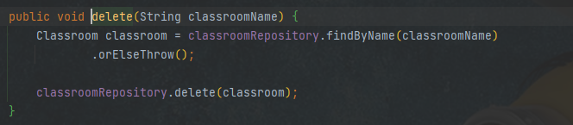

*Figure 3‑38: delete method on classroom in service*

If the classroom was deleted with succes a message will apear, othewise an error will occur.

The second set of functionalities which an admin can made is the CRUD operations on users. The admin cand delete, update, read or create new users, both teachers and students. He is the only one who can do this such operations. Here is necessary to mention the fact that a new admin cannot be created. The admin is just one account and it was created when the applicationn was developed.

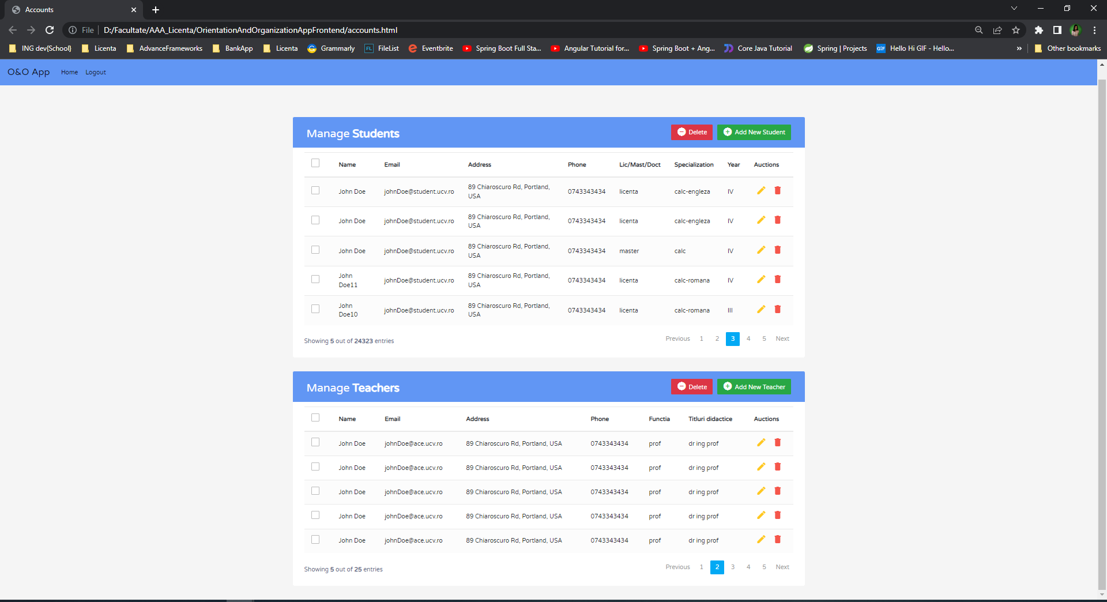

*Figure 3‑39: CRUD operations on USER entity*

The above figure present the tabels witg the users. We have two tables one for students and one for teachers. This is made in the same way because in this way we will be able to set the role automatically. When a new user is added the admin needes to present the all personal date and the specially fields for which type of user is. In the next figures we will see the dto’s for bith teacher and users. This models are used when a new user is added.

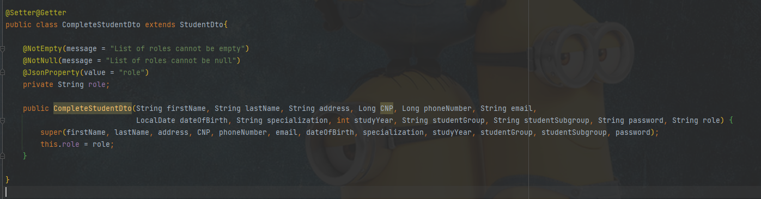

*Figure 3‑40: example of StudetDao class for add new entry*

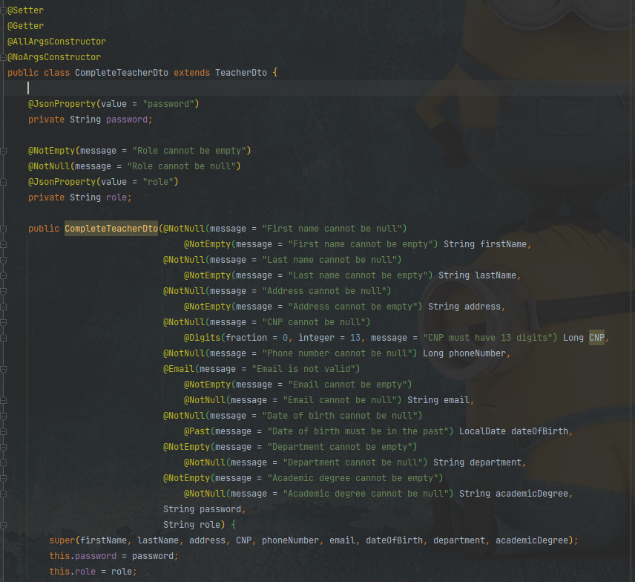

*Figure 3‑41: example of TeacherDao class*

We see the fact that each model extend other models. This is because we need more models for other functionalities, but due to the constructos all the parameters of the two models can be clearly seen.Furthermore, we can see all the validation that are made on the request dtos. For example the string fields cannot be null or empty. Rather, almost all fields cannot be null or empty because for example we can not have a student withot name, or without date of birth.

What can be empty or null is the password, because this will be generated automatically and it will contains some special caracters. We create a function which generate unique password. Each password will contains nine characters: 3 letters, 3 digits and 3 special caracters. This function is called evry time when a new user is added in the database.

Because the password must be given to the users these will be clearly saved in the database.

The third set of functionalities is the one for the activity entity. Because the admin has fully access he can add a new activity with a default reserved classroom. He can delete any nactivity, or update. In the next figure 3-41 we see a table with all activities.

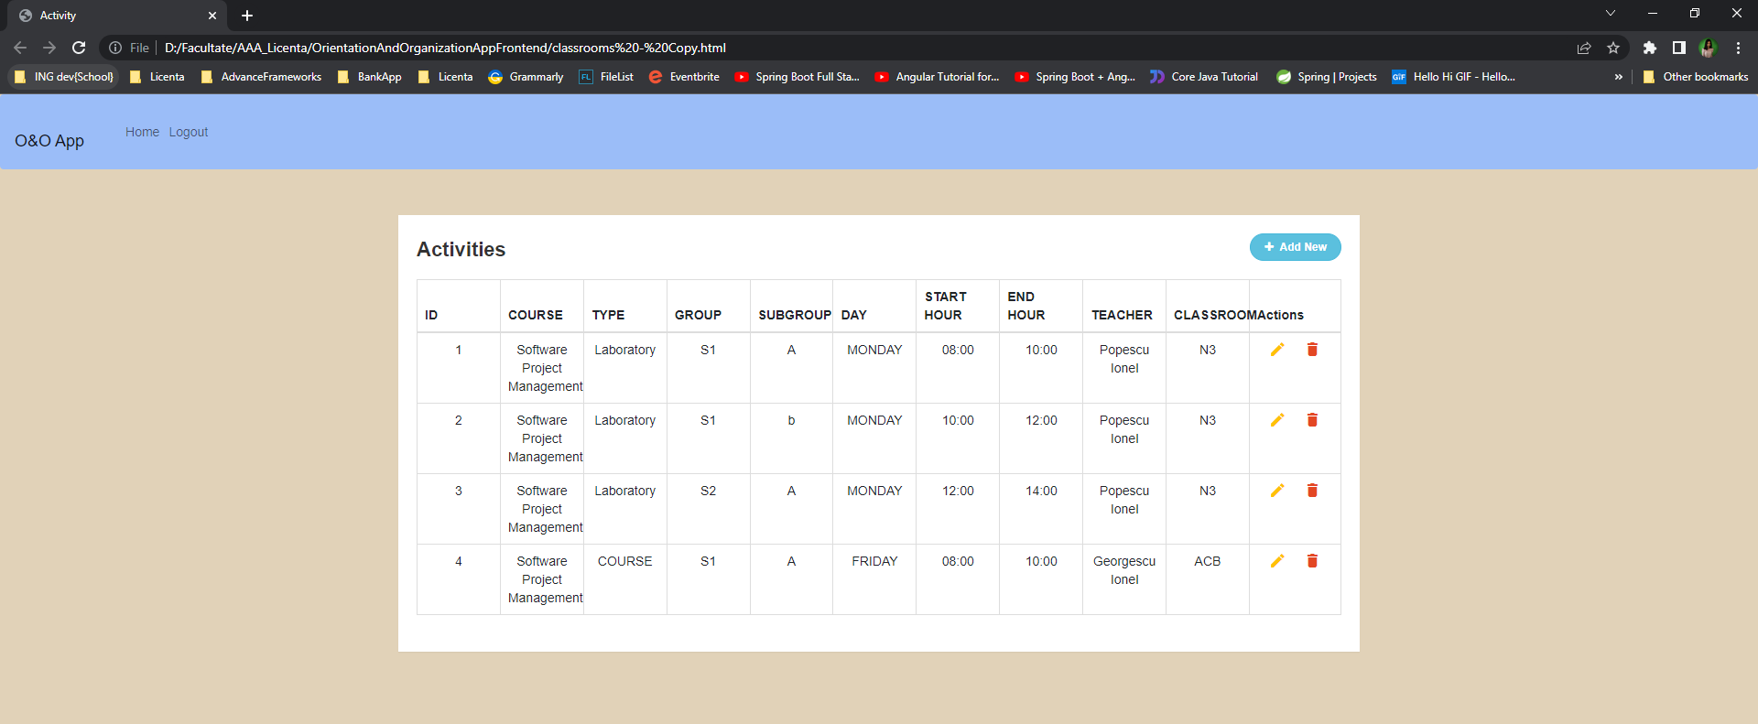

*Figure 3‑42 : list of all activities for admin user*

If the admin wants to delete a activity just press the red trash from right side. If he wants to update some fields just press the yellow button from the actions column. And if he wants to add a new activity he press + Add New button from right side.

Now we will discuss about backend implementations for each functionality. In order to get all the activities from database we creat a new endpoint which find all activities. In the next figure 3-42 we will see it. As we discuss earlyer in the getActivities() method from controller is called findActivities() method from service, where is called findAll() method ofers by JPA Repository from ActivityRepository class.

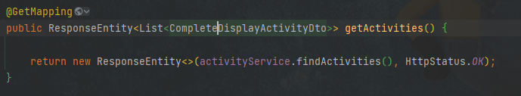

*Figure 3‑43 : getActivities() method from controller*

In order to delete an activity just called delete method and give as paramater the id of the activity that the admin wants to delete. We can see the endpoint who does this operation in figure 3-43

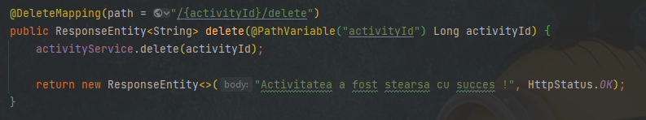

*Figure 3‑44 : delete method from activity controller*

To update an existing activity is enogh to give the id of the acticity us path variable and a request body who contains the field which we want to update and his value. The activity will be searched in the database according to the id. Then the field will be updated and the new activity will be saved again in database. As we discuss earlyer because it’s a update and not a save we use path verbs for endpoint.

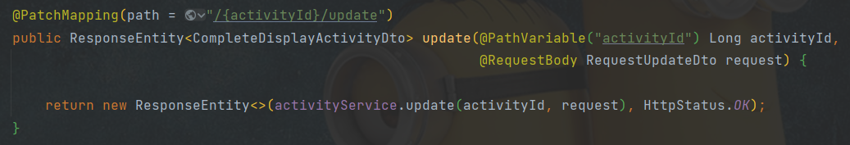

*Figure 3‑45 : update method from activity controller*

The most complex functionality who can be done on Activity entity is the save one. Here we need a new dto with all the fields, the admin will complete them and after that the new activity is saved in database. Because it contains a teacher, a course and a classroom and we received from UI just their ids, first we need to search in database those types of objects.

In the next figure 3-45 we will see the code from service which makes this whole process of saving a new activity. As we said before, the activity saved by admin contains already the reserved classroom. This method return a new DisplayActivityDto because we wan’t to expose the all fields from an activity.

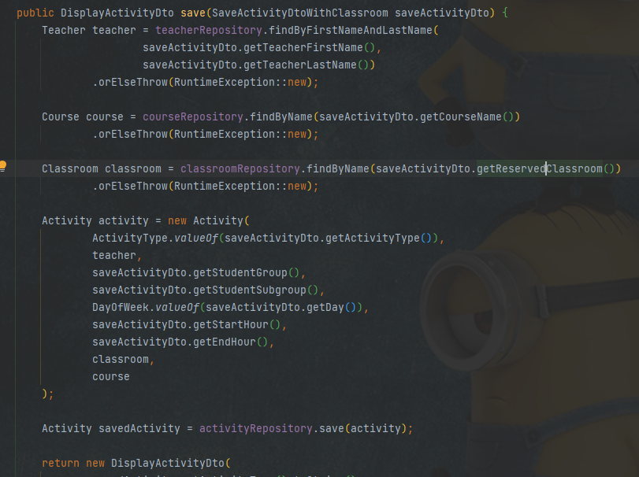

*Figure 3‑46 : save method from activity service*

## Testing

We know that there are several types of testing. First, the biggest categories and the ones that everyone knows are manual testing and automatic testing. The application is not tested automatically, it has not been tested together and integration tests.

Orientation and Organization App has been tested manually. Two types of people from two different backgrounds were chosen, a 50-year-old man and a 20-year-old woman to see a difference of opinion. They tested the web platform, replacing the three types of users. We showed them a little overview of the application, explaining what it can do to know exactly what to test.

We will discuss in turn about the impression of each user in the pair. We received both positive and negative feedback about what we could have done better or what we could bring new to the platform.

The 50-year-old user said that the application seemed very useful to him and that he wished he had had such help during his college years. He first tested the functionality for an ADMIN. Here he said that everything is very intuitive, a message appears at every step, and the pages are very nicely developed. Then he went on to test functionality for a STUDENT, here I received negative feedback but constructive. We were told that we should improve our search functionality. The design is not very nice. And the last functionalities tested were those for the PROFESSOR type user. Here we also put access to be tested in detail the functionality of adding a new activity. Small improvements have been found, but it works well overall.

The second person who test our application is a 20-year-old girl, student currently. It was chosen intentionally, to have the opinion of a student type user. She first tested the functionality for students. Everything here went well. She had the same remark, as the first user, to visually improve the search part for a certain class. Then she went on to test functionalities for teachers. Everything went exactly as it should, and the user had nothing to add. In the end, it remains to be seen what options an ADMIN has. Here I received feedback related to the operation of updating some entities. We were asked to be more careful about which data exactly can be updated and which data cannot. For example, a user's CNP can never be updated. Two improvements I received from both users were:

* Add a back button on each page so that the user can return to the previous page
* Users can add a profile picture in the PROFILE section

# CONCLUSION

## General Conclusions

To develop this application was a big challenge but help me a lot to increase my knowledge about software development. Furthermore, I put in practice all I know about Java and frontend language and all I learned in the last four years.

For creating this documentation was necessary a lot of investigation and research, but because I already know the programing languages used, I know exactly what to look for. Most of the time I spent when I wrote the first chapter, where the research was bigger.

From my opinion to use Java was a wise choice, because being an object-oriented language everything was easy to use. This programming language is up to date and very well developed. Even if it is used in a proportion of 70% for mobile applications, it also handles very well in the development of web ones, including a special framework Spring MVC.

What could have been improved here is the fact that Java 8 was used in the project and the latest version is Java 17. Maybe it wouldn't have been a good idea to use the latest version, being recently released, but I consider that at least Java 11 could be used. But starting the road with an older version I did make the upgrade.

For database I chose to use a relation one, MySQL to be able to combine perfectly with the language used on the backend side. For my perspective a relational database is the best choice. Besides the fact that it is much easier to use, and you can learn very quickly, the offer and a structural architecture. But this is just an opinion, for databases I consider that the choice is made depending on what you need and how you like to work. I am very sure that there are people who prefer to work with non-rational databases

The frontend part it was the hardest thing for me to do. I cannot say I am a fan of frontend languages ​​and for this reason everything here has been quite confusing. But I think that in the time I had, everything turned out the way I wanted. Here we used a Java helper framework (tymeleaf) to create the links between the already existing endpoints on the backend and frontend side. But here would have been many other options that could have been adopted.

Furthermore, what needed to be improved is the testing part. A minimal, manual test was performed, just to test more of the front end of the application, but I consider that an application for the backend part was also necessary. Both unit tests and integration tests had to be performed for the endpoints created in the controller. The application is in develop process and for this reason no tests have been added, but they will be created in time.

The “Orientation and Organization App” is an intelligent system whose focus is both on finding a class and on helping teachers. This offers teachers the opportunity to add a new activity for one of the courses in which they are coordinator and generate a list with free classrooms. Beside those the app has many other functionalities.

In conclusion, I hope the project is a good one and will meet will all requirements asked from a Computer Science Engineer.

## Future Developments

Exists some improvements that can be made on the “Orientation and Organization App”. We will describe each one in the next chapter. Furthermore, we will present what we want to do next and what new options we will add.

Improvements:

* Add back button on pages: at this moment does not exist a back button on pages. This is a necessary one because for example a student or a teacher wants to go back from the search options page to the main menu. This is a necessary improvement that was discovered in the testing process. Both persons who test out the app suggested us to add this type of button on each page.
* Increase security and store password encrypted in database: because the password is generated automatically and the faculty, more precision the admin, must communicate the password of each user, at this moment it is stored. Here the solution is to create a new microservice that generates the password, send it to the user, and then stores encoded in the database.
* Use Model Mapper to map a DTO to an entity: in this moment the mapping process is done” manually”. We have an example in the next figure. An improvement can be to use model mapper library. This will help a lot and the code quantity that a developer writes will decrease

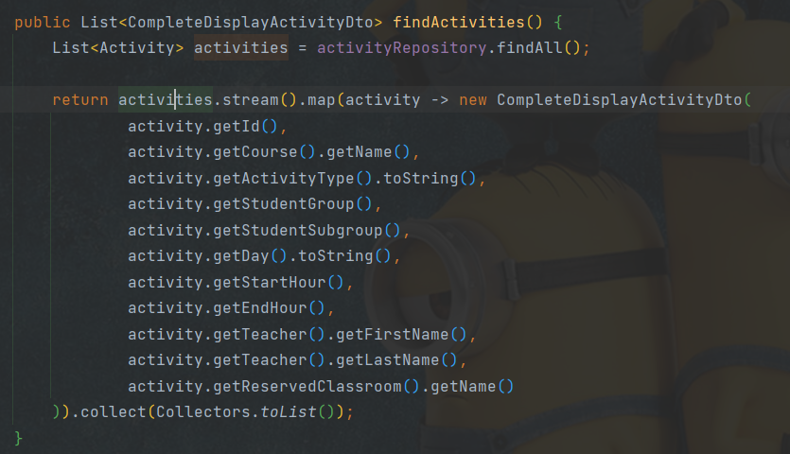

*Figure 4‑1 : mapping process*

New futures:

* Profile picture for a user in front-end views this functionality is marked, but in the backend part, it is not implemented. This can be a new future that is not mandatory but can be an interesting one. For example, each user can add a profile picture after he logs in.
* More CRUD operations for the admin user. For example, for schedule entity at this moment did not exist operations like create, delete, update this type of entries. This must be presented to have a correct flow of the application.

# BIBLIOGRAFIY

[1]: <https://www.discovertec.com/blog/evolution-of-technology>- Donny Lamey “The evolution of technology”

[2]: <https://www.tititudorancea.com/z/ion_luca_caragiale_istoria_se_repeta.htm>- I.L.Caragiale

[3]: <http://despresucces.ro/timpul-inseamna-bani-stii-sa-iti-gestionezi-timpul/>- “TIMPUL ÎNSEAMNĂ BANI! ȘTII SĂ ÎȚI GESTIONEZI TIMPUL?” - Andra Secelean 2013

[4]: <https://blogs.oracle.com/javamagazine/post/the-top-25-greatest-java-apps-ever-written> May 1, 2020 - Alexa Morales

[5]: <https://codecool.com/ro/blog/top-limbaje-programare/> - “Java in top 10 programming language”

[6]: <https://www.w3.org/Style/CSS/#specs>- “Cascading Style Sheets home page : What is CSS?”

[7]: “Expert One-on-One: J2EE Design and Development “– Rod Johnson 2002

[8]: <https://www.toptal.com/spring/spring-security-tutorial> - Ioram Gordadze, “Spring Security with JWT for REST API”

[9]: <https://en.wikipedia.org/wiki/Database> - Database

[10]: <https://en.wikipedia.org/wiki/Java_(programming_language)> – Java Wikipedia

[12]: <https://ro.wikipedia.org/wiki/HTML5> - official documentation HTML 5

[13]: <https://www.thymeleaf.org/documentation.html> - Thymeleaf official documentation

[14]: <https://www.techtarget.com/searchdatamanagement/definition/SQL> - “Structured Query Language (SQL)” by By Peter Loshin

[15]: <https://www.javatpoint.com/dbms-sql-command> - JavaTPoint SQL commands

[16]: <https://hackr.io/blog/what-is-frameworks> - “What is a framework?” – article

[17]: <https://ro.wikipedia.org/wiki/Spring_Framework> - Spring Framework official documentation

[18]: <https://www.techtarget.com/searchapparchitecture/definition/RESTful-API> - RESTful API by Alexander S. Gillis

[19]: <https://www.indeed.com/career-advice/career-development/non-functional-requirements-examples> - “9 Nonfunctional Requirements Examples” by Indeed Editorial Team

[20]: <https://stackify.com/find-hibernate-performance-issues/> - “How to Find Hibernate Performance Issues in Development and Production” – by THORBEN JANSSEN, 6 August 2021

BOOKS:

[21]: “*Clean Code: A Handbook of Agile Software Craftsmanship*” 1st Edition by Robert C Martin; publisher Pearson

[22]: “*Thinking in Java*” 4th Edition by Bruce Eckel in 2006

[23]: “*Headfirst HTML5 Programming*” by Elisabeth Robson and Eric Freeman published in 2011

# SOURCE CODE

<https://github.com/ileanavasilica99/Licenta>

# WEB APPLICATION

<https://github.com/ileanavasilica99/Licenta>

# CD / DVD

# Index

B

Bibliografie 9

C

CUPRINSUL xi

D

Dimensiuni 3

F

Figuri 4

Formulele matematice 4

I

Ilustrațiile 4

L

Legenda 6

LISTA FIGURILOR xii

LISTA TABELELOR xiii

R

Referințe web 10

S

Structura documentului 2

T

Tabele 5